Document Revision History
Version | Date | Description of Changes
W7.1F | July 12, 2021 | Finalized workproduct
W7.1.3 | July 01, 2021 | Addressed State review comments.
W7.1.2 | May 06, 2021 | Revised and published.
WPDT 06 | Jun. 17, 2014 | Revised and published.
WPDT 05 | Feb. 28, 2014 | Revised and published.
WPDT 04 | Dec 18, 2013 | Revised and published.
WPDT 03 | Sept 13, 2013 | Third draft
WPDT 02 | July 14, 2013 | Second draft
WPDT 01 | July 01, 2013 | Initial draft

Provider Claims and Billing Assistance Guide
Table of Contents
1. What is NCTracks 1
2. Who’s Who 3
2.1 CMS 3
2.2 NC DHHS 3
2.3 DHB 3
2.4 DPH 3
2.5 ORH 4
2.6 DMH/DD/SAS 4
2.7 County DSS 4
2.8 PCG 4
3. NCTracks Provider Portal 7
3.1 Secure Provider Portal Message Center 7
3.2 Provider Portal Functions 7
3.3 Why Use the Provider Portal? 8
3.4 Provider Portal Signup 8
3.5 Taxonomy 8
3.5.1 Healthcare Provider Taxonomy Code Set (HCPTC) 8
3.5.2 Healthcare Provider Taxonomy Codes (HCPTC) and NCTracks 9
3.5.3 Location and Healthcare Provider Taxonomy Codes (HCPTC) and NCTracks 10
3.5.4 Atypical Providers and Healthcare Provider Taxonomy Codes (HCPTC) in NCTracks 10
4. Provider Provisioning 11
4.1 North Carolina Identity Management (NCID) 11
4.2 User Access 11
5. Provider Enrollment 13
5.1 Enrollment Application 13
5.1.1 Group Provider Enrollment 13
5.1.2 Individual Provider Enrollment 13
5.1.3 Atypical Provider Enrollment 13
5.1.4 Other Enrollment Requirements 13
5.1.5 Provider Enrollment and Re-enrollment Fees 14
5.2 Payment of Provider Fees 14
5.3 Qualifications for Enrollment 15
5.3.1 Licensure, Accreditation, Endorsement, and Certification 15
5.3.2 Service Location 15
5.3.3 Re-verification Requirements 15
6. SkillPort Training 17
7. Community Care of North Carolina/Carolina ACCESS (CCNC/CA) 19
7.1 CCNC/CA Provider Participation and Enrollment 20
7.1.1 Requirements for Participation in Primary Care Case Management (PCCM) Program 20
7.1.2 Advanced Medical Home and CA Participation 21
7.2 Beneficiary Enrollment in CCNC/CA 21
7.3 Enrolling Beneficiaries with a CCNC/CA Medical Home at the Provider’s Office 22
7.4 Member Identification 23
7.4.1 Beneficiary Education 23
7.4.2 Process for Referring a CCNC/CA Beneficiary to Another Provider 24
7.4.3 Pregnancy Care Management and Care Coordination for Children 24
8. Verifying Beneficiary Eligibility 25
8.1 Verifying Eligibility 25
8.1.1 Verification Methods 25
8.2 Verifying Beneficiary Eligibility Using the NCTracks Portal 25
8.2.1 Individual Eligibility Response 26
9. Prior Approval 31
9.1 General Requests for Prior Approval 31
10. Submitting Electronic Claims 33
10.1 Billing Claims Electronically 33
10.1.1 Time Limits for Filing Claims 33
10.1.2 Billing Professional (CMS-1500/837P) Claims 33
10.1.2.1 Creating a Professional Claim in NCTracks 34
10.1.3 Billing Institutional (UB-04/837I) Claims 34
10.1.3.1 Creating an Institutional Claim in NCTracks 34
10.1.4 Billing Dental (ADA 2019/837D) Claims 35
10.1.4.1 Creating a Dental Claim in NCTracks 35
10.1.5 Creating a Pharmacy Claim in NCTracks 36
10.1.6 Creating a Pharmacy Claim Reversal in NCTracks 36
10.1.7 Submitting Payments from Other Payers and Line Items 38
10.1.8 Transmitting Attachments and Submitting the Claim 39
10.1.8.1 Submitting the Completed Claim 39
10.2 NC Medicaid Implementation of the National Correct Coding Initiative 40
10.2.1 Additional Correct Coding Edits Implementation 41
10.3 Trading Partner Agreements 41
10.4 Billing with Software Obtained from a Contractor 42
10.5 Billing with Software Written by Provider’s Office or Company 42
11. Claim Forms and Resolution 43
11.1 Pharmacy Claims 43
11.2 Processing Claims Without a Signature 43
11.3 Time Limit Overrides 43
12. Claim Details and Options Post-Submittal 45
12.1 Transaction Control Number (TCN) 45
12.2 Causes for Adjustments 45
12.3 Claim Status and Claim Copy 45
12.4 Resubmitting a Claim Through the Provider Portal 47
12.4.1 Claim Information Tab on Create Claim Screen 47
12.4.2 Attachments Tab on Create Claim Screen 48
12.5 Health Check Claim Details 48
13. Resolving Denied Claims 51
13.1 CCI/MUE Denials 52
13.1.1 MUE Denials 52
13.1.2 Appealing a CCI/MUE Denial 52
13.2 Provider Claims Denial Reconsideration Reviews 53
14. Remittance Statement 55
14.1 Remittance Statement Sections and Subsections 56
14.1.1 Remittance Statement Layouts 56
14.1.2 Paper Remittance Layout 57
14.1.3 Paid Original Claims Page 57
14.1.4 Denied Original Claims Page 59
14.1.5 Summout Page 61
14.1.6 Payment Header Page 61
14.1.7 Summary Page 62
15. Provider Training 65
15.1 Provider Training and Workshop Enrollment 65
15.2 SkillPort 65
15.2.1 How to Access and Register for Training in SkillPort 65
Appendix A. Resources 67
Appendix B. Referral Numbers and Points of Contact (For Providers) 69
Appendix C. SkillPort Training Materials 71

List of Exhibits
Exhibit 7-1. CCNC/CA Provider Enrollment 20
Exhibit 8-1. Verify Recipient Screen 26
Exhibit 8-2. Provider Eligibility Response Screen (1 of 3) 27
Exhibit 8-3. Provider Eligibility Response Screen (2 of 3) 29
Exhibit 8-4. Provider Eligibility Response Screen (3 of 3) 29
Exhibit 10-1. Creating a Professional Claim 34
Exhibit 10-2. Creating an Institutional Claim 35
Exhibit 10-3. Creating a Dental Claim 36
Exhibit 10-4. Creating a Pharmacy Claim 36
Exhibit 10-5. Creating a Pharmacy Claim Reversal 37
Exhibit 10-6. Create Pharmacy Reversal Screen 37
Exhibit 10-7. Other Payers Screen 38
Exhibit 10-8. Attachments Screen 39
Exhibit 10-9. Submit Claim 40
Exhibit 12-1. Transaction Control Number 45
Exhibit 12-2. Claims Status Menu Option 46
Exhibit 12-3. Claim Status Request Screen 46
Exhibit 12-4. Claim Status Request Result 47
Exhibit 12-5. Claims Draft Search Screen 47
Exhibit 12-6. Claim Information Tab 48
Exhibit 12-7. Create Professional Claim Screen for Submit 48
Exhibit 14-1. Provider Message Center Inbox 56
Exhibit 14-2. Denied Original Claims Page of Remittance Statement 60
Exhibit 14-3. Summout Page of Remittance Statement 61
Exhibit 14-4. Payment Header Page of Remittance Statement 62
Exhibit 14-5. Summary Page of Remittance Statement 63

1. What is NCTracks
In December 2008, the North Carolina Department of Health and Human Services (NC DHHS) awarded a contract to Computer Sciences Corporation (CSC), which is now CSRA State and Local Solutions LLC, A General Dynamics Information Technology Company, to develop and implement a NC Medicaid Management Information System (NCMMIS) in support of healthcare administration for multiple DHHS divisions. The system, named NCTracks, is a multi-payer system that replaces and coordinates processing between the following:
- Existing Legacy Medicaid Management Information System (MMIS+) for the Division of Health Benefits (DHB)
- Integrated Payment and Reporting System (IPRS) for the Division of Mental Health, Developmental Disabilities, and Substance Abuse Services (DMH/DD/SAS)
- Purchase of Medical Care Services (POMCS) for the Division of Public Health (DPH) and the Office of Rural Health (ORH)
Providers contracted by Local Management Entities (LMEs) to perform state-funded services for DMH/DD/SAS continue to submit their claims to the LMEs.
The NCTracks Provider Portal serves as the conduit for training, determining claim status, retrieving Remittance Statements, and other functions essential to effectively managing business with NC DHHS.

This Page Intentionally Left Blank

2. Who’s Who

2.1 CMS
The Centers for Medicare & Medicaid Services (CMS) is the federal agency that regulates and oversees all state Medicaid and State Children’s Health Insurance Programs (SCHIP) programs. CMS is responsible for enforcing the administrative simplification provisions of the Health Insurance Portability and Accountability Act of 1996 (HIPAA), including national standards for electronic healthcare transactions, code sets, and National Provider Identifiers (NPIs). In addition, CMS is responsible for developing the National Correct Coding Initiative (NCCI), a program designed to prevent improper payments when a provider submits incorrect procedure code combinations or to avoid payments of units of service that are medically unlikely to be correct, and other initiatives impacting healthcare.

2.2 NC DHHS
The NC DHHS oversees the administration of numerous healthcare programs in the State of North Carolina, including Medicaid. DHHS is divided into 30 divisions and offices, which fall under four broad service areas: health, human services, administrative, and support functions. DHHS is the largest agency in state government, responsible for ensuring the health, safety, and well-being of all North Carolinians, providing the human service needs for fragile populations such as the mentally ill, deaf, blind, and developmentally disabled.

2.3 DHB
The mission of the Division of Health Benefits (DHB, previously the Division of Medical Assistance or DMA) is to provide access to high-quality, medically necessary healthcare for eligible North Carolina residents through cost-effective purchasing of healthcare services and products. DHB administers the NC Medicaid and NC Health Choice (NCHC) programs by:
- Interpreting federal laws and regulations
- Overseeing regulatory affairs (Medicaid State Plan and NC Administrative Code)
- Providing outreach and education to providers and beneficiaries
- Establishing, publishing, and monitoring clinical policy
- Establishing all fees and rates
- Establishing and overseeing provider enrollment and termination requirements
- Maintaining third-party insurance files and conducting beneficiary financial recovery activities
- Maintaining the Eligibility Information System (EIS)
- Administering Medicaid managed care programs
- Publishing provider bulletins and other communication tools
- Monitoring program fraud, waste, and abuse

2.4 DPH
The Division of Public Health (DPH) promotes disease prevention, health services, and health promotion programs that protect communities from communicable diseases, epidemics, and contaminated food and water. DPH programs include:
- Child Service Coordination
- Children with Special Diet Needs
- Coronavirus Disease 2019 (COVID-19) Response in North Carolina
- Early Hearing Detection and Intervention Services (Newborn hearing screening and follow-up)
- Newborn Home Visit Services
- Pediatric Health Care: Exams and Treatment for Children
- Special Supplemental Nutrition Program for Women, Infants and Children (WIC)
The Administrative, Local, and Community Support (ALCS) section of the DPH provides both direct and indirect services to the public and local health agencies. Much of its work focuses on providing support that allows the business of public health to operate as seamlessly as possible, so that the DPH may better serve the public.

2.5 ORH
The North Carolina Office of Rural Health (ORH) supports equitable access to health in rural and underserved communities. To achieve its mission, ORH works collaboratively to provide funding, training, and technical assistance for high-quality, innovative, accessible, cost-effective services that support the maintenance and growth of the State’s safety net and rural communities.
The ORH assists underserved communities by improving access, quality, and cost-effectiveness of healthcare. ORH administers over 300 contracts designed to expand access to high-quality healthcare for rural and underserved populations, allowing ORH to return over 88% of its budget directly to North Carolina communities. In addition, ORH provides in-depth technical assistance to North Carolina’s healthcare safety net system.

2.6 DMH/DD/SAS
The Division of Mental Health, Developmental Disabilities, and Substance Abuse Services (DMH/DD/SAS) is charged with implementing the state’s public mental health, developmental disability, and substance abuse service system and priorities.
Per the North Carolina Commission for Mental Health, Developmental Disabilities and Substance Abuse Services webpage, the Commission established the Rules Committee as well as the Advisory Committee to carry out its two primary functions: rulemaking and serving in an advisory capacity to the Secretary of the NC DHHS. Committee membership consists of current members of the Commission who are appointed to the committees by the Chair of the Commission. The Division works closely with the NC Division of State Operated Healthcare Facilities, which manages all mental health, developmental disability, and substance abuse facilities. For more information on DMH/DD/SAS, please see the division webpage.

2.7 County DSS
Each county Department of Social Services (DSS) is responsible for the following:
- Determining beneficiary eligibility for NC Medicaid and NCHC programs
- Enrolling beneficiaries in Fee-For-Service (FFS) managed care plans
- Maintaining all beneficiary eligibility files

2.8 PCG
Public Consulting Group (PCG) is the contractor that supports the Office of Compliance and Program Integrity in post-payment claims review initiatives. It is also one of the State’s Recovery Audit Contractors (RACs). PCG is working on behalf of DHB to assist providers with mandated screening and training requirements in accordance with federal regulations: 42 CFR 455.410 and 455.450.

This Page Intentionally Left Blank

3. NCTracks Provider Portal
The NCTracks Provider web portal is designed with ease of use and productivity in mind. Providers have the capability through the portal to manage aspects of their business within the NCTracks system. The enhanced functionality allows providers to more efficiently manage changes, update records, add services to a location, participate in electronic communications and listservs, as well as manage affiliations to billers, groups, and organizations. The functionality allows for the automation of the Prior Approval (PA) process, checking beneficiary eligibility, Checkwrite information, Remittance Statements, etc. The majority of the automation accessible by the provider allows for real-time processing and information retrieval. The portal serves to enhance providers’ access, productivity, and management of their information, and expedite business processes.
Providers are able to participate in web-based tutorials, register for instructor-led classes and seminars, and request site visits through the Provider Portal. Many training materials are available for retrieval and downloading.
Providers are able to establish and manage staff access to their records, use electronic signature capabilities, and upload documentation to further streamline and reduce time-consuming paper processing.
Note: Providers must have an NCID to access the Secure Provider Portal. Please see Section 4.1 North Carolina Identity Management (NCID) for information on how to obtain an NCID.

3.1 Secure Provider Portal Message Center
- Announcements – Provide information regarding key activities within the program.
- Inbox – Communications from NCTracks to providers are displayed in the Inbox. Communications may include Remittance Statements, approval letters, key communications, etc.
- Quick Links – Provide easy access to health-related information including Medicaid Bulletins, provider manuals, training, and other DHHS websites.
- Subscriptions – Providers are able to select available subscription services to custom tailor their home page.

3.2 Provider Portal Functions
All provider functions can be launched from the Provider Portal home page using the navigation tabs presented at the top of the screen. Once in the Provider Portal, users with authorized access have the ability to:
- Perform provider enrollment and maintenance functions
- Inquire on beneficiary eligibility and enrollment¹
- Submit original claims, claim adjustments, and PA requests
- Review claims payment and status information¹
- Access PA requests¹
- Access State-approved forms
- Access provider training information including provider workshop registration, training materials, training evaluation forms, bulletins, broadcast e-mails, and supporting documentation for training
- Register to receive notifications and/or facilitate communications appropriate to each DHHS division and Health Plan supported by NCTracks

3.3 Why Use the Provider Portal?
The Provider Portal provides key information from Medicaid claims and other sources that may be missing from the patient provider chart or electronic health record. The portal allows providers to:
- View information on patient encounters that occurred outside of the provider’s local clinic or health system (including hospitalizations, emergency department visits, primary care and specialist visits, laboratory, and imaging)
- Review medication regimen (including fill history and adherence indicators, and whether medications have been prescribed by other providers)
- Access patient education materials and evidence-based practice tools for screening and assessment, health coaching, and disease management
- Retrieve medication information for patients in multiple languages, in video or print format
- Access population management reports and quality metrics for the provider’s patient population

3.4 Provider Portal Signup
How do I access the Provider Portal?
1. To register, go to https://www.nctracks.nc.gov/content/public/providers/getting-started.html and follow the steps to access NCTracks Currently Enrolled Provider (CEP) Registration.
2. Complete the registration form and select Save.
3. An e-mail notification is sent to providers and their networks. A network representative will contact providers or their designees to complete their registration.

3.5 Taxonomy
NCTracks uses the NPI, the Healthcare Provider Taxonomy Code (HCPTC), and the service location in the processing of claims. Taxonomy codes for the specified provider reporting levels (attending, rendering, service facility, etc.) are required on all claim types except pharmacy (although pharmacy providers select taxonomy codes in the Provider Enrollment/Re-enrollment process for their provider records).

3.5.1 Healthcare Provider Taxonomy Code Set (HCPTC)
The Healthcare Provider Taxonomy Code Set is a hierarchical code set that consists of codes, descriptions, and definitions. Healthcare Provider Taxonomy Codes are designed to categorize the type, classification, and/or specialization of healthcare providers. The Code Set consists of two sections: Individuals and Groups of Individuals and Non-individuals. The Code Set is updated twice a year, effective April 1 and October 1. The Code Set is available from the Washington Publishing Company and is maintained by the National Uniform Claim Committee, www.NUCC.org. The Code Set is a HIPAA standard code set. As such, it is the only code set that may be used in HIPAA standard transactions to report the type/classification/specialization of a healthcare provider when such reporting is required.
When applying for an NPI from the National Plan and Provider Enumeration System (NPPES), a healthcare provider must select the Healthcare Provider Taxonomy Code or code description that the healthcare provider determines most closely describes the provider’s type/classification/specialization, and report that code or code description in the NPI application. The Healthcare Provider Taxonomy Code or code description information collected by NPPES is used to help uniquely identify healthcare providers in order to assign them NPIs, not to ensure that they are credentialed or qualified to render healthcare.

3.5.2 Healthcare Provider Taxonomy Codes (HCPTC) and NCTracks
The Healthcare Provider Taxonomy Codes and code descriptions that healthcare providers select when applying for NPIs may or may not be the same as the categorization used by DHHS in enrollment and credentialing activities. Many DHHS providers submit taxonomy codes on claims today. It is important that providers use the appropriate taxonomy code from their provider records based on the service rendered and location.
Providers may have more than one taxonomy code per location. New DHHS providers who enroll designate their taxonomy during the enrollment process, using a drop-down list based on the Division-specified provider enrollment, licensing, and credentialing guidelines. Existing providers are able to view and/or update their taxonomy codes using the Manage Change process in the NCTracks Provider Portal. Providers are encouraged to verify their taxonomy codes and locations at https://npiregistry.cms.hhs.gov/. This page allows providers to enter their NPI and view the taxonomy codes and locations currently on record for that NPI. Providers can change their taxonomy codes through the Enrollment function in the NCTracks Provider Portal.
In case of discrepancies or omissions, providers must make corrections online at https://www.nctracks.nc.gov/content/public/providers.html Changes to a provider’s taxonomy must be verified. While a change is pending, providers could have claims denied. To prevent this, providers should use the enrollment Status and Management screen in the secure NCTracks Provider Portal to ensure the changes have been accepted before submitting claims. (See the How to View and Update Taxonomy Job Aid on the NCTracks Provider User Guides & Training page.)
Note: Claims submitted in NCTracks with codes that do not match the provider taxonomy will be denied.
To facilitate timely adjudication, it is important that providers use the appropriate taxonomy code from their NCTracks provider record based on the service rendered and the rendering/attending provider location when submitting claims to the NCTracks system. Providers must also verify the billing provider taxonomy code on the claim matches one of the taxonomy codes listed on the NCTracks billing provider record and is appropriate for the claim being billed.
Both the group/billing provider and the rendering provider have their own taxonomy codes, which should be reflected on the claim (unless the provider’s specific provider billing guide instructs them otherwise; some exceptions that may use a group taxonomy code assigned to the rendering provider include DMH, Durable Medical Equipment [DME], Non-Emergency Medical Transportation [NEMT], DD, and SAS).
Providers submitting batch/X12 claims electronically (not via the web portal) should indicate the rendering/attending provider location. Taxonomy codes are required on all claim types except pharmacy Point-of-Sale (POS) claims.

3.5.3 Location and Healthcare Provider Taxonomy Codes (HCPTC) and NCTracks
Because NCTracks relies on taxonomy codes to assign service locations properly, submitted claims with service codes that do not correlate to provider taxonomies and locations on file are denied. Accurate information on where services are rendered is vital to ensuring claims process correctly in NCTracks. NCTracks uses the service facility address to assign the appropriate service location and ultimately the appropriate payment. In cases where the submitted service address does not match provider address data on file, or invalid service address information is on file (such as a P.O. Box), claims can fail.

3.5.4 Atypical Providers and Healthcare Provider Taxonomy Codes (HCPTC) in NCTracks
The NPI Final Rule stipulates that only entities who meet the definition of “healthcare providers” found at 45 CFR 160.103 are eligible for NPIs. There are a number of entities who do not meet this definition who are therefore not eligible for NPIs, but whose services are payable by NCTracks. The NPI Final Rule refers to these entities as “atypical service providers” because the services they render are not “healthcare” services. Examples are NEMT services and physical alterations to living quarters for the purpose of accommodating disabilities. Atypical providers use a system-generated provider identification number to file claims and not an NPI.

4. Provider Provisioning

4.1 North Carolina Identity Management (NCID)
Access to the NCTracks Provider Portal requires an NCID. Providers who already have an NCID can use it to access NCTracks. To obtain an NCID, go to https://ncid.nc.gov and select the “Register” link.
Users who have an NCID but have forgotten the password can go to https://ncid.nc.gov and select the Forgot Password link. NCID registration and passwords are controlled by the NC Office of Information Technology Services (ITS).
An NCID is required to complete the Currently Enrolled Provider (CEP) Registration, to register for training, and to access the secure NCTracks Provider Portal. Providers must obtain an NCID for their Office Administrator (OA) and additional NCIDs for staff who intend to access NCTracks.

4.2 User Access
OAs (owners or managing employees) can control the access that each member of their provider organization has to information in the NCTracks Provider Portal, by granting role-based access to NCTracks features based on user job responsibilities. Access settings are controlled per NCID; therefore, each person who will access the NCTracks Provider Portal must have their own NCID. Sharing NCIDs is not advised for security reasons and because it is a single login system (performing multiple actions under one NCID logs out that NCID).
OAs can designate one or more User Administrators to administer ongoing system access. OAs (or User Administrators) can then grant staff members access to the portal, as desired. OAs and User Administrators are encouraged to complete the OA training available in SkillPort, the NCTracks Learning Management System (LMS).

This Page Intentionally Left Blank

5. Provider Enrollment

5.1 Enrollment Application
Providers must be enrolled in NC DHHS to render services. Providers must complete and submit a Provider Enrollment application for their specific provider type. The online Enrollment application is available through the NCTracks Provider Portal.
All applications, including applications for a new practice location, are screened and assigned a categorical risk level of limited, moderate, or high. Provider types and specialties that fall into the moderate- and high-risk categories may be subject to a pre-enrollment site visit, unless a screening and site visit has been successfully completed by Medicare or another state agency, as well as fingerprinting and payment of the Federal Fee. Senate Bill 496 §108C-3 further defines provider types that fall into each category. If a provider fits within more than one risk level, the highest level of screening is applicable (42CFR 455.450, NC Session Law 2011-399, NCGS 108C-(3)). Providers can also find their taxonomy enrollment requirements in the Provider Permission Matrix available under Quick Links on the NCTracks Provider Enrollment page.
NCHC providers must still enroll directly with NCTracks, regardless of whether or not these providers accept Medicaid. This also applies to providers billing Medicaid for children ages 0 – 3, as children these ages are not covered by the LME-MCO (Managed Care Organization) waiver at this time.
Providers participating in NCHC only do not have the option to participate in FFS Managed Care programs.

5.1.1 Group Provider Enrollment
Providers who want to enroll as groups must complete and submit an online Provider Enrollment Application via the NCTracks Provider Portal for their specific provider type categorized as ‘organization’. Examples of group providers are dental offices, hospitals, skilled nursing facilities, home health agencies, and physician offices.

5.1.2 Individual Provider Enrollment
Providers who want to enroll as individuals must complete and submit an online Provider Enrollment Application via the NCTracks Provider Portal for their specific provider type categorized as ‘individual’. Examples of individual providers are dentists, physicians, physician assistants, and nurse practitioners.

5.1.3 Atypical Provider Enrollment
“Atypical” providers are providers who do not provide healthcare services and are not issued NPI numbers. Atypical providers are individuals or businesses that bill Medicaid for services rendered but do not meet the definition of a healthcare provider according to the NPI Final Rule 45 CFR 160.103 (for example, NEMT providers). Atypical providers use system-generated provider identification numbers to file their claims.

5.1.4 Other Enrollment Requirements
In accordance with Sections 6401(a), 10603 and Section 1866(j) of the Affordable Care Act (ACA), prior to initially being enrolled, all providers are required to attend trainings and some providers are required to undergo screenings (depending on risk level and state and federal requirements) as designated by the NC DHHS in accordance with NCGS § 108C-9, including, but not limited to, the following.
- How to avoid common billing errors
- Audit procedures, including explanation of the process used to extrapolate audit results
- How to identify beneficiary fraud
- How to report suspected fraud or abuse
- Due process and appeal rights

5.1.5 Provider Enrollment and Re-enrollment Fees
In accordance with Section 1866(j) (2) (C) (i) (I) of the ACA, an Application Fee is required from providers and suppliers who are newly enrolling, revalidating, or establishing a new practice location, or in response to a CMS revalidation request. Depending on provider risk level, a Federal Fee may be required as well. The Federal Fee changes yearly; fee amounts by year may be found under Quick Links on the NCTracks Provider Enrollment page by selecting the “Federal Fees & NC Enrollment Fees by Year” link.
Session Law 2011-145 Section 10.31(f) (3) mandates that DHB collect a $100 NC Application Fee from providers upon initial enrollment with the Medicaid/NCHC programs and at 5-year intervals when the provider is re-credentialed (re-verification).
Initial enrollment is defined as an enrollment by a provider who has never enrolled to participate in the Medicaid/NCHC programs. Re-verification is the process that providers must complete every 5 years to remain active Medicaid/NCHC providers.
The $100 NC Application Fee is required for:
- New initial Enrollment applications when the provider applies for NC Medicaid and/or NCHC. (Note: This requirement does not include Out-of-State [OOS] Lite providers.)
- Re-verification applications when the provider is active in NC Medicaid and/or NCHC.
- Applications that are abandoned, withdrawn, or denied, upon re-submission of the application.
- OOS Lite provider requests to become a full provider.
The $100 NC Application Fee is never required for Re-enrollment applications.
More information on enrollment and re-enrollment fees can be found on the NCTracks Federal Fee and NC Application Fee FAQs page.

5.2 Payment of Provider Fees
Providers can submit payment with their electronic application by selecting their method of payment through the NCTracks Provider Portal. Providers receive an electronic payment summary and confirmation. Providers are encouraged to print the confirmation page for their records. Payments are posted and the payment status is updated in the NCTracks Provider Portal within 2 business days of being received.
Providers should make every effort to remit payment promptly. Applications are not processed if payment is not received. If payment is not received within 30 days of the date of the application, the application is abandoned, and the applicant is required to reapply. Payment of the Federal Fee is an automated part of the enrollment process. Providers have the option to submit payment directly after completion of the application. If payment is not submitted, the application shows in a Payment Pending status. The application is not processed until payment is submitted.

5.3 Qualifications for Enrollment
The general requirements for provider enrollment are as follows.

5.3.1 Licensure, Accreditation, Endorsement, and Certification
Providers must be licensed, accredited, endorsed, and/or certified according to the specific laws and regulations that apply to their service type. Enrollment qualifications vary, but ALL providers must complete an application and an NC DHHS Provider Administrative Participation Agreement. All providers are responsible for maintaining the required licensure, endorsement, and accreditation specific to their provider type to remain qualified and are required to notify NC DHHS immediately if a change in status occurs. For detailed information regarding specific requirements for each provider type, refer to the Provider Permission Matrix under Quick Links on the NCTracks Provider Enrollment page.
Note: Behavioral Health MCOs that operate under the DMH/DD/SAS Plan waiver are responsible for enrolling behavioral health providers in their respective provider networks.

5.3.2 Service Location
Services must be provided at a site within the State of North Carolina or, for some services, within 40 miles of the North Carolina border. OOS providers are eligible for enrollment only under the following conditions:
- For reimbursement of services rendered to Medicaid beneficiaries in response to an emergency, or if travel back to the state would endanger the health of the beneficiary.
- For reimbursement of prior-approved non-emergency services.
- For reimbursement of medical equipment and devices that are not available through an enrolled provider located within the State of North Carolina or within the 40-mile border area.
OOS providers are required to adhere to all North Carolina rules, regulations, laws, and statutes governing healthcare delivery under the North Carolina Medicaid program. OOS providers are also required to sign the NC DHHS Out of State Lite Provider Participation Agreement during enrollment, which can be found at https://www.nctracks.nc.gov/content/public/providers/provider-enrollment/terms-and-conditions/NC-DHHS-Out-of-State-Lite-Provider-Participation-Agreement.html.
For a list of ZIP Codes that are within the 40-mile border area, refer to the North Carolina Border ZIP Codes list on the NCTracks website at https://www.nctracks.nc.gov/content/public/providers/provider-enrollment/supporting-information/zip-codes.html. Providers should be affiliated with each location and organization where they render services.

5.3.3 Re-verification Requirements
Each enrolled provider is required to be re-verified every 5 years to confirm that they continue to meet the conditions of participation for enrollment as a Medicaid provider.

This Page Intentionally Left Blank

6. SkillPort Training
There are several provider instruction guides in this document; however, the preferred method for getting the most up-to-date information is accessing the correlated guide in the SkillPort LMS. The correlated document name is noted in each section of this document for the provider to refer to in SkillPort. Please note that a provider’s NCID must be provisioned by the provider’s OA to have access to training in SkillPort. The following training types are available:
- CBTs (Computer-Based Training): Courses the provider can go through at any time to learn about a specific subject.
- ILTs (Instructor-Led Training): Live courses led by training instructors. Courses may be on-site or remote via WebEx (live web conference where the provider shares their screen), and the form of the course is specified by folder in SkillPort. *Please note that these courses are not listed in the chart below, as they are offered at specific times and should be registered for in SkillPort.
- PUGs (Participant User Guides): PUGs are guides that provide guidance on how to use a system as a whole, often with steps for that system or program overall. They help the reader gain understanding and comprehend basic use of a complex system. (Example: a PUG about how to file a claim)
- JAs (Job Aids): Job Aids are read-through, task-specific instructions. They walk the user through an action step-by-step to complete a task. They are excellent references if the user is not able to attend a class. (Example: How to Add or Change a Billing Agent and Other Claim Submission Options in NCTracks)
PUGs, Job Aids, reference documents, and CBT modules can be used at any time. ILT modules are live trainings and therefore only available when announced. Occasionally, a PowerPoint slide deck from an ILT is uploaded if available, but the course information is usually only available at the time and date the live class is held.
Note: Based on the seating availability at each training venue, it is mandatory that users register for each session that they plan on attending. If more than one person from a provider’s office or association plans on attending, they must register separately under their own NCIDs.
A list of courses available is provided in Appendix C. However, for the most up-to-date content, please check SkillPort.

This Page Intentionally Left Blank

7. Community Care of North Carolina/Carolina ACCESS (CCNC/CA)
DHB operates a statewide Primary Care Case Management (PCCM) program for the state’s Medicaid beneficiaries called Carolina ACCESS (CA). The CA program was initiated in 1991 and successfully increased access to medical homes. By enrolling beneficiaries into a medical home, the need for beneficiaries to seek primary care services and basic care in hospital emergency departments is reduced.
In 1998, CCNC was created using the existing CA infrastructure and established 14 community networks that created local systems of care designed to achieve long-term quality, cost, access, and utilization objectives in the management of care for Medicaid beneficiaries. These 14 regional networks covered all 100 North Carolina counties. Each network has an administrative entity that contracts with DHB. North Carolina continues to operate the original CA PCCM program; however, in 2019, the 14 regional networks were restructured into six regional networks. Each network has an administrative entity that contracts with DHB. Most primary care providers (PCPs) are now members of a regional network.
Population management, care management, and coordination of treatment and prevention are provided to beneficiaries enrolled with a network provider. Networks and providers receive increases in the per member/per month (PM/PM) management fee for enhanced case management services for subsets of populations that are high-risk, high-acuity, high-cost, and frequently have complex co-morbid conditions. In addition to the services listed below, enhanced services include, but are not limited to, a comprehensive and integrated package of high-risk screening/assessment, triage, referral, hospital transitions, pharmacy reviews, medication reconciliation, inpatient, and emergency department diversion with care management across the continuum of care.
The networks provide population health management by:
- Furnishing preventive services and information
- Systematic data analysis to target beneficiaries and providers for outreach, education, and intervention
- Monitoring system access to care, services, and treatment including linkage to a medical home
- Monitoring and building provider capacity
- Monitoring quality and effectiveness of interventions to the population
- Supporting the medical home through education and outreach to beneficiaries and providers
- Facilitating quality improvement activities that educate, support, and monitor providers regarding evidence-based care for best practice/national standards of care
The networks provide disease management by:
- Educating network providers on evidence-based standards of care to ensure that high-risk, high-acuity beneficiaries receive appropriate care
- Educating beneficiaries about disease states and self-management
Currently, the six CCNC regional networks include more than 6,000 physicians across North Carolina.
Note: Networks are paid PM/PM management fees based on the number and type of enrollees.

7.1 CCNC/CA Provider Participation and Enrollment

7.1.1 Requirements for Participation in Primary Care Case Management (PCCM) Program
DHB and NCTracks work together to recruit and enroll PCPs into the CCNC/CA program. NCTracks is responsible for processing the applications and enrolling providers into the program. DHB is responsible for establishing PCP participation requirements, assisting providers in carrying out CCNC/CA policies and procedures, and recruiting providers into the program.
For more information, please visit https://medicaid.ncdhhs.gov/providers/programs-and-services/community-care-north-carolinacarolina-access-ccncca.
NCTracks allows providers to enroll in CCNC/CA and select a CCNC/CA contact person. Providers whose applications have been denied or voided may reapply at any time unless a sanction has been imposed upon the provider’s participation by DHB.
Providers are required to report any changes regarding their practice’s status to NCTracks. Failure to report a change in practice status may result in termination from the Medicaid program, or PCCM program and sanctions imposed by DHB, including recoupment of PM/PM management fees. To report changes to the Medicaid program, CCNC/CA providers must submit a Manage Change Request (MCR) through the NCTracks Provider Portal.
Note: The following instructions on how to enroll in CCNC, as well as information on how to update or terminate CCNC enrollment, are available in the most up-to-date form in SkillPort in the Job Aid PRV242 Changing or Terminating CCNC_CA Enrollment.
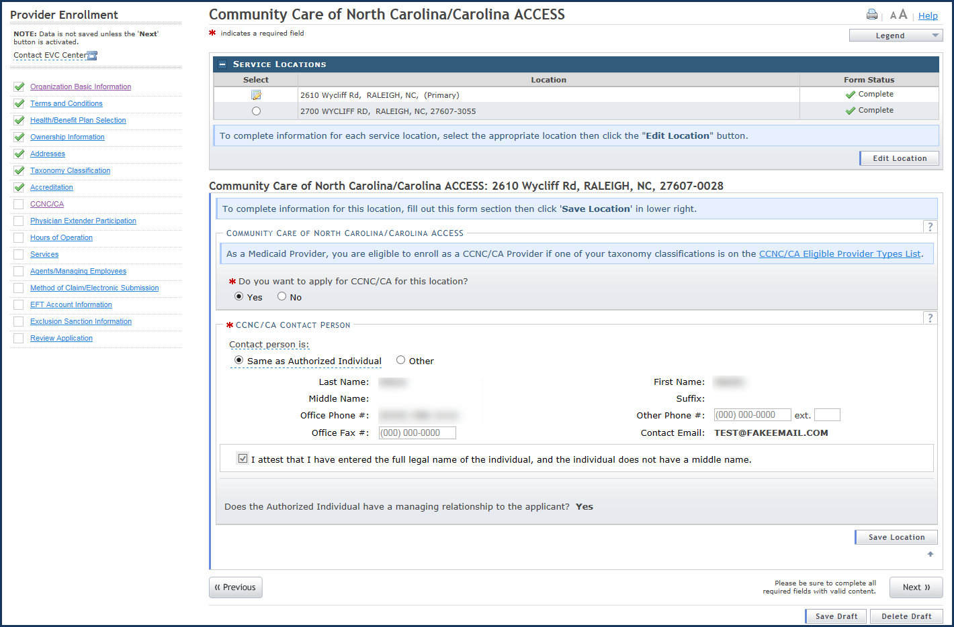
6
5
4
3
2
1
Exhibit 7-1. CCNC/CA Provider Enrollment
Step | Action
1 | Select the radio button next to the desired location.  Note: Applications for CCNC/CA must be completed for each service location.
2 | Select the Edit Location button to continue.
3 | Select Yes to the question “Do you want to apply for CCNC/CA for this location?”.
4 | Select the radio button for Same as Authorized Individual or Other in the CCNC/CA Contact Person section.  Note: When Same as Authorized Individual is selected, the information is populated with the authorized individual’s name. When Other is selected, the user must complete the required fields.
5 | Select the Save Location button (if applicable). Note: All service locations must have a status of Complete in the Form Status field. If Incomplete displays for any location, the user must edit the location and complete all required fields.
6 | Select the Next button to continue.

7.1.2 Advanced Medical Home and CA Participation
As per the NC DHHS Advanced Medical Home (AMH) webpage, “DHHS developed the Advanced Medical Home (AMH) program as the primary vehicle for delivering care management as the state transitions to Medicaid managed care. The AMH program builds on the Carolina ACCESS program.”
The AMH program requires Prepaid Health Plans (PHPs) to delegate certain care management functions to AMHs at the local level. In order to provide these care management functions, AMHs may work with their affiliated healthcare system or make an arrangement with an entity called a Clinically Integrated Network, a Care Management vendor, or other population health entity. To ensure that beneficiaries across the state are receiving high-quality care management, DHHS developed standards for AMHs and will be responsible for initially certifying that practices meet AMH criteria.
For more information about the AMH program and enrollment starting with CA, please see the NC DHHS Advanced Medical Home (AMH) webpage.

7.2 Beneficiary Enrollment in CCNC/CA
The county DSS is responsible for enrolling FFS beneficiaries with a CCNC/CA medical home as part of Medicaid Managed Care (more information about Health Plans can be found here). Enrollment requirements are based on the beneficiary’s Medicaid program aid category and classification of eligibility.
Beneficiaries in any of the mandatory categories that receive Medicare have optional enrollment.
Beneficiaries whose enrollment is mandatory are informed about the CCNC/CA program and enrolled during the Medicaid application process. Beneficiaries are strongly encouraged to select a medical home from the list of PCPs serving their county of residence. Beneficiaries who do not choose a medical home are assigned by the county DSS based on location, medical history, and restrictions of the provider.
Enrollment considerations:
- In areas that do not have access to CCNC/CA PCPs for all potential enrollees, efforts are made to preserve existing provider-patient relationships.
- Beneficiaries whose third-party insurance is a Health Maintenance Organization (HMO) or who have Tri-Care may be exempted from CA if their PCP does not participate with CCNC/CA.
- At the discretion of the county DSS and the provider, beneficiaries may choose a provider whose CA agreement does not include their county of residence in the provider’s service area. Beneficiaries who need transportation assistance are generally limited to their county of residence or to a contiguous county.
- Each family member may have a different medical home.
- Enrollees in either the Medicaid or NCHC program may request to change their medical home without cause at any time by contacting the county DSS.
North Carolina has chosen to enroll beneficiaries of both Medicaid and Medicare (known as duals, or dually eligible beneficiaries) on an opt-out basis when the beneficiary is in a category that grants full Medicaid coverage. This means that dual beneficiaries are notified that they have been enrolled and given the name of the medical home to which they have been enrolled. They are also notified that they should contact the local DSS to choose a different provider or to declare their intention to opt out of the program.
Note: Providers may not charge copayments for services covered by both Medicare and Medicaid. A dual beneficiary may be charged a copayment if required for services that are not covered by Medicare but are covered by Medicaid.
All optional beneficiaries are notified via letter or verbally by the case worker at the local county DSS that they can request to enroll, disenroll, or change medical homes at any time. This information is also contained in the educational material provided to all beneficiaries at enrollment. Beneficiaries can communicate their choice either in writing or verbally to the local DSS.
Although federal regulations state that foster children must remain optional for enrollment in a managed care program, the Fostering Connections to Success and Increasing Adoption Act of 2008 requires each state to provide a plan to ensure ongoing oversight and coordination of healthcare for foster children. North Carolina is meeting this need by enrolling foster children in a medical home through the CCNC/CA program. Guardians of children in foster care can choose to withdraw a foster child from enrollment or change PCPs at any time by notifying the DSS verbally or in writing.

7.3 Enrolling Beneficiaries with a CCNC/CA Medical Home at the Provider’s Office
- Providers must inform beneficiaries of their right to choose any CCNC/CA PCP who is accepting new beneficiaries, and their right to change PCPs at any time pursuant to processing deadlines.
- Enrollment is optional for some beneficiaries, including pregnant women and Medicare beneficiaries. Providers must inform optional beneficiaries of their right to disenroll in the program at any time in the future. Optional beneficiaries may discuss enrollment options by contacting their local DSS. For a listing of all the county DSS offices, refer to www.ncdhhs.gov/dss/local/.
- Complete the enrollment form and it send to the CCNC/CA contact at the DSS in the county where the beneficiary resides. The form can be found on the DHB website at https://medicaid.ncdhhs.gov/providers/programs-and-services/community-care-north-carolinacarolina-access-ccncca.
- Provide the Medicaid beneficiary with a CCNC/CA Member handbook. A copy of the handbook is available on the DHB website at https://medicaid.ncdhhs.gov/providers/programs-and-services/community-care-north-carolinacarolina-access-ccncca.
Providers with questions regarding enrolling beneficiaries can contact their county DSS Regional Consultant.

7.4 Member Identification
CCNC/CA enrollees are identified by information on their Medicaid identification (MID) card. The name, address, and daytime and after-hours telephone numbers of the medical home/PCP are listed on the MID card. To ensure they have the most current PCP enrollment information, providers are encouraged to verify this information when they verify Medicaid eligibility at each visit.
The following table identifies mandatory, optional, and ineligible beneficiaries by program aid category.
Mandatory | Optional | Ineligible
AAF/Work First – Cash Assistance with Medicaid | MPW – Medicaid for Pregnant Women | MQB and RRF/MRF
MIC (N) and MIC (1) – Medicaid for Infants and Children | HSF – State Foster Home Fund | Beneficiaries in Deductible status
MAABD – Medicaid for the Aged, Blind or Disabled (Without Medicare) | IAS – Medicaid with IV-E Adoption Subsidy and Foster Care | Community Alternatives Program (CAP) cases with a monthly deductible
MAF – Medicaid for Families | End Stage Renal Disease Patients | Aliens eligible for Emergency Medicaid only
SAD – Special Assistance for the Disabled (Without Medicare) | SSI beneficiaries under age 19 | Nursing Facility residents (does not include ICF-I/DD [Intermediate Care Facilities for those with intellectual and developmental disabilities])
SAA – Special Assistance for the Aged (Without Medicare) | Native Americans (members of a federally recognized tribe) | MAF-D – Family Planning Waiver
MIC-J and MIC-K children enrolled in NCHC | MAABD – Medicaid for the Aged, Blind or Disabled (With Medicare) | MIC-L – NCHC Re-enrollment Buy-In
Native Americans | - SAA – Special Assistance for the Aged (With Medicare)  - SAD – Special Assistance for the Disabled (With Medicare)  - Benefit Diversion Cases | MAF-W – Breast and Cervical Cancer Medicaid

7.4.1 Beneficiary Education
The county DSS is responsible for beneficiary education about CCNC/CA. Enrollees are provided with a CA member handbook (available in English and Spanish) that informs them of the rights, responsibilities, and benefits of being a member.
It is also important for PCPs, as the coordinators of care, to be actively involved in patient education. CCNC/CA PCPs are expected to contact all new enrollees by telephone or in writing within 60 days of enrollment to schedule an appointment to establish a medical record for the new enrollee. New enrollees are identified in Section 1 of the monthly Carolina ACCESS Provider Enrollment Report.
Providers should inform each enrollee about the following:
- The availability of medical advice 24 hours a day, 7 days a week, and the preferred method for contacting the PCP
- The enrollee’s responsibility to bring his/her MID card to each appointment
- The need to contact the PCP for a referral before going to any other doctor
- The need to contact the PCP before going to the emergency department, unless the enrollee feels that his or her life or health is in immediate danger
- The importance of regular preventative care visits, such as Health Check screenings for children, immunizations, checkups, mammograms, cholesterol screenings, adult health assessments, and diabetic screenings
- The availability of additional information for enrollees from the county DSS
- Copayment requirements

7.4.2 Process for Referring a CCNC/CA Beneficiary to Another Provider
Coordination of care protocol is a required component of CCNC/CA. The CCNC/CA provider should promptly arrange referrals for medically necessary healthcare services that are not provided directly and document referrals for specialty care in the beneficiary’s medical record. However, a CCNC/CA payment authorization number is not required for claims processing.
- Authorization is not required for services provided in a hospital emergency department or for an admission to a hospital through the emergency department. Referrals for routine follow-up care after discharge from a hospital must be made to the PCP. Referrals to a specialist for follow-up care after discharge from a hospital do not require PCP authorization but should be coordinated through the PCP’s office.
- If surgery is recommended, CCNC/CA PCPs are required to refer beneficiaries for a second opinion at the request of beneficiaries.
- If beneficiaries disagree with their PCP’s decision regarding referrals for specialty services or other care, the beneficiaries should be advised of their option to choose a different CCNC/CA PCP.
- All referrals should be documented in the beneficiary’s medical record.

7.4.3 Pregnancy Care Management and Care Coordination for Children
The Pregnancy Care Management program provides care management for the pregnant Medicaid population. In most cases, care management is provided by the local Health Department, through a contract with the local CCNC network. Each Pregnancy Medical Home (PMH) has a care manager assigned to the practice. Providers must submit all risk screenings to their care manager within 7 business days. Care managers are expected to conduct a thorough assessment of all priority patients within 30 days.
Non-PMH prenatal care providers and other community agencies may refer a patient for assessment with a pregnancy care manager, who evaluates the patient’s level of need and develops a care plan accordingly.
Pregnant Medicaid patients identified as being at risk for poor birth outcomes receive individualized case management services. The level of service provided is in proportion to the individual’s identified needs. Care managers closely monitor the pregnancy through regular contact with the physician and patient to promote a healthy birth outcome. Care managers are an integral part of the patient’s care team.

8. Verifying Beneficiary Eligibility

8.1 Verifying Eligibility
A beneficiary’s eligibility status may change from month to month if financial and household circumstances change. For this reason, providers are required to verify a Medicaid beneficiary’s eligibility each time a service is rendered.

8.1.1 Verification Methods
Providers may verify a beneficiary’s eligibility using the following methods:
- NCTracks Provider Portal
- Automated Voice Response System (AVRS)
- Electronic Data Interchange (EDI) (batch)

8.2 Verifying Beneficiary Eligibility Using the NCTracks Portal
Online eligibility verification through NCTracks allows access to the Health Plans and benefits for which the recipient qualifies. NCTracks also offers a secure Recipient Portal where recipients can check their eligibility status with Medicaid, NCHC, DPH, and ORH.
For example, a beneficiary may be enrolled in a specific North Carolina Medicaid program, such as Medicaid for Infants and Children (MIC) or Medicaid for Adults with Disabilities (MAD). The program abbreviations can be identified in the NCTracks Benefit Plans Mapped to DHB Eligibility Coverage Codes document on the NCTracks Provider Policies, Manuals, Guidelines and Forms page. A provider verifying beneficiary eligibility can view the Health Plan in which the beneficiary is enrolled (Medicaid, NCHC, Public Health, Mental Health, or Rural Health). Beneath the Health Plan is a list of benefits the recipient is eligible to receive.
Using the Verify Recipient screen, providers are able to conduct eligibility inquiries on an individual beneficiary by using the provider’s NPI number and various combinations of the beneficiary’s information (to include: Recipient ID, First Name, Date of Birth, Last Name and Social Security Number) and Date of Service (DOS).
When conducting a DHB eligibility inquiry, providers can verify beneficiary eligibility up to 36 months prior to the current month of the inquiry in NCTracks. Past this time period, providers must contact the DHB Claims Analysis Unit.
When conducting a DPH eligibility inquiry, the dates of service may be back as far as 36 months prior to the current month and up to 12 months beyond the current month.
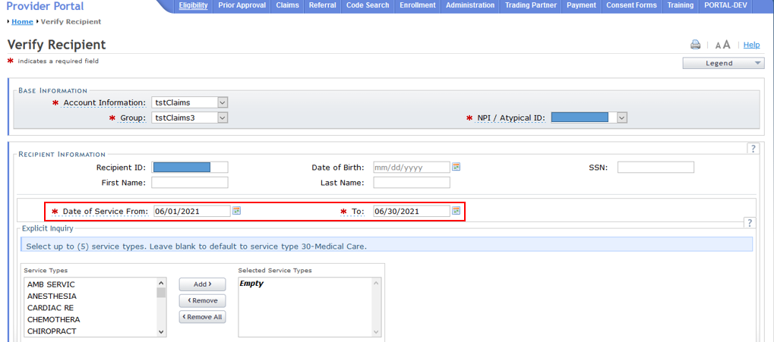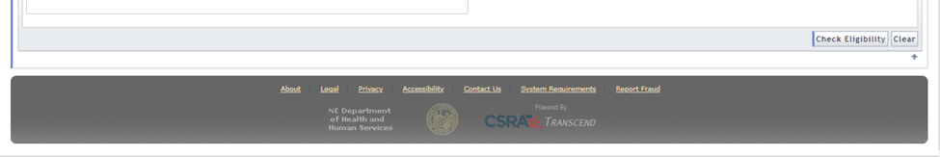
6
5
3
1
2
4
Exhibit 8-1. Verify Recipient Screen
Step | Action
1 | Base Information: Select the Account, Group, and NPI/Atypical ID.
2 | Recipient Information: Enter recipient data using one of the following combinations:  - Recipient ID  - Recipient ID, Last Name, and Date of Birth  - Recipient ID, First Name, and Last Name  - First Name, Last Name, and Date of Birth  - Date of Birth and Social Security Number
3 | Date of Service: Enter From date or use the calendar icon to select a date.
4 | Date of Service: Enter To date or use the calendar icon to select a date.
5 | Optional: Select Service Type and select Add.
6 | Select the Check Eligibility button to display search results.

8.2.1 Individual Eligibility Response
The Provider Eligibility Response screen displays the search results based on the given search criteria. A provider can view the Search Criteria, Recipient Information, and Coverage Details.
When applicable, recipient response details include information regarding benefit plans, monthly liability amounts, Medicare, other insurance, and service limits.
Note: Verification of eligibility is not a guarantee of payment. DPH cannot guarantee payment because funding for services may be exhausted. If eligibility is denied and the provider confirms eligibility was verified by giving the tracking number, DHB will honor the eligibility verification.
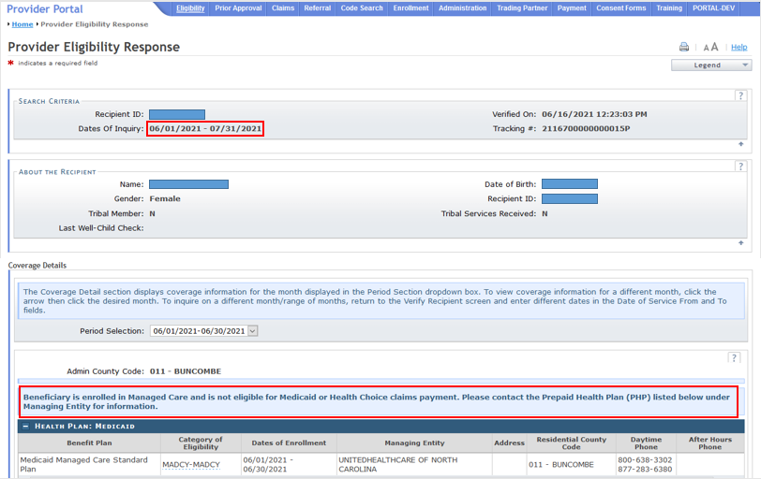
4
3
5
2
1
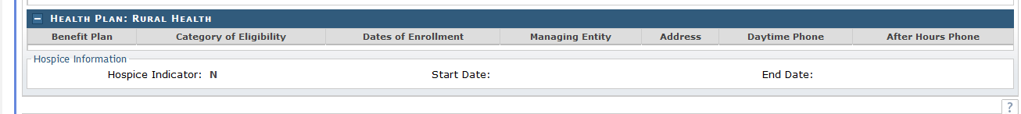
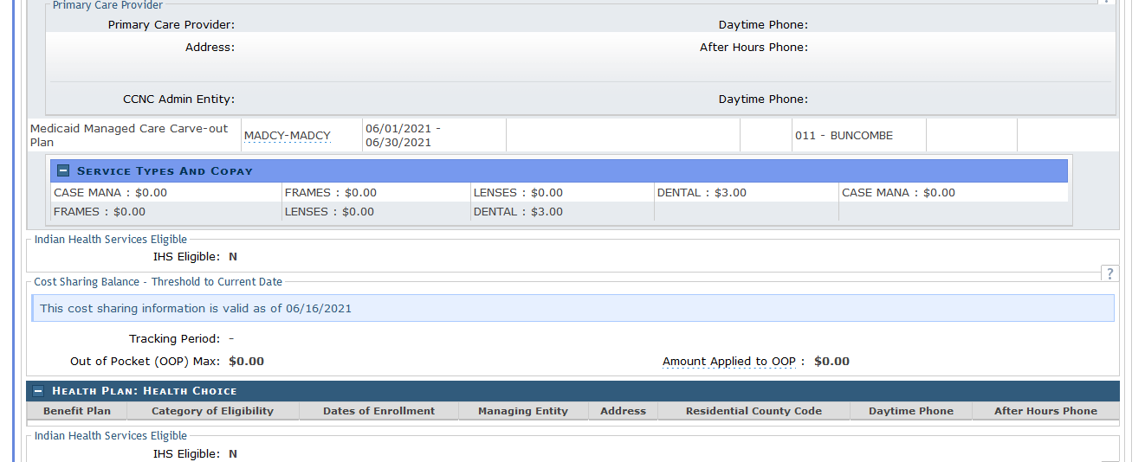
8
7
6
Exhibit 8-2. Provider Eligibility Response Screen (1 of 3)
Section | Description
1 | Search Criteria displays the search criteria used for the results. This section includes Recipient ID, Dates of Inquiry, Verified On (date and time), and Tracking #.
2 | About the Recipient displays recipient demographic information. This section includes: Name, Date of Birth, Gender, Recipient ID, Tribal Member, Tribal Services Received, and Last Well-Child Check. Last Well-Child Check displays the month, date, and year of the last well-child checkup the recipient received.  Note: A ‘Y’ value in the Tribal Member field indicates that the recipient is a member of a federally recognized Native American tribe. An ‘N’ value indicates that the recipient is not a member of a federally recognized Native American tribe.  A ‘Y’ value in the Tribal Services Received field identifies a tribal member who has been treated or referred by an Indian Health Services (IHS)/tribal provider. An ‘N’ value identifies a tribal member who has NOT been treated or referred by an IHS/tribal provider. No value, blank, or spaces in this field indicates that the recipient is not a member of a federally recognized Native American tribe.
3 | Coverage Details displays information for each calendar month within the dates of inquiry. To change inquiry dates, the user must select the appropriate date span from the Period Selection drop-down menu.
4 | The Administrative County Code displays.  Below the Administrative County Code, users will see the message:  “Beneficiary is enrolled in Managed Care and is not eligible for Medicaid or Health Choice claims payment. Please contact the Prepaid Health Plan (PHP) listed below under Managing Entitity for information.”  Next, the first Health Plan displays. This is the county that determines eligibility  Note: When the future month is returned on an eligibility request the disclaimer message displays under the Admin County Code section of the request.
5 | Health Plan – Displays eligibility information for the period requested for the following Health Plans: Medicaid, NCHC, Public Health, and Rural Health. Each Health Plan section includes: Benefit Plan, Category of Eligibility, Dates of Enrollment, Managing Entity, the Address of the Managing Entity, the Recipient’s Residential County Code, the Managing Entity Phone Number, and the Managing Entity’s After Hours Phone Number.  The Managing Entity field displays an agency or other entity that manages and administers the Benefit Plan.  Primary Care Provider displays Primary Care Provider, Daytime Phone Number, Address, and After Hours Phone Number, the Network Entity, and their Daytime Phone Number.
6 | Indian Health Services Eligible displays the details of the recipient’s IHS eligibility data. If the IHS Eligible indicator displays ‘Y’, this means the recipient is not a tribal member but is eligible to receive services at an IHS facility. If the IHS Eligible indicator displays ‘N’, this means the recipient is not a tribal member and is not eligible to receive services at an IHS facility.
7 | Cost Sharing Balance – Threshold to Current Date includes a statement that the cost-sharing information is valid as of <the date of inquiry>, the Tracking Period (State fiscal year), Out-of-Pocket (OOP) Max, and Amount Applied to OOP. This information is provided only when the recipient is enrolled in a benefit plan that requires recipient cost sharing, such as enrollment fees, premium payments, and co-pays, and that has an OOP maximum (the threshold).
8 | Hospice Information displays Yes or No to indicate whether the beneficiary has elected to use the hospice benefit or not. If the hospice period covers any part of the calendar month selected, the information is provided.
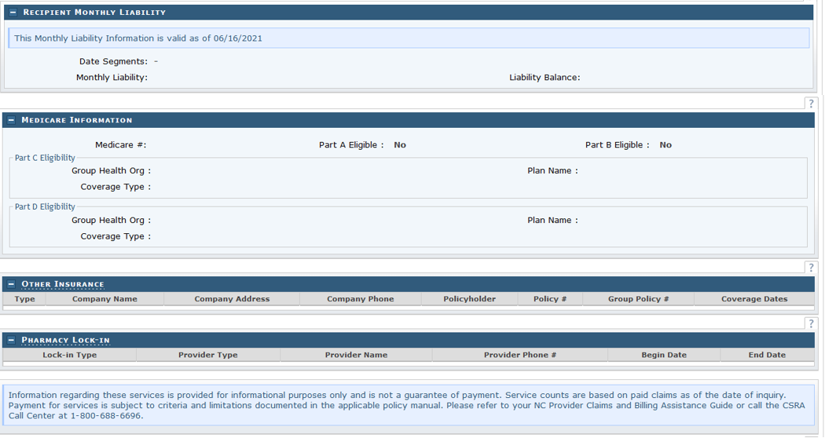
11
12
9
10
Exhibit 8-3. Provider Eligibility Response Screen (2 of 3)

Section | Description
9 | Recipient Monthly Liability displays the recipient’s monthly liability totals and balance. This section contains Monthly Liability valid through date, Date Segments, Monthly Liability, and Liability Balance.
10 | Medicare Information displays the recipient's Medicare insurance information. This section contains Medicare #, Part A Eligible, and Part B Eligible. In addition, this section displays Part C & D Eligibility details, Group Health Org, Coverage Type, and Plan Name.
11 | Other Insurance displays information regarding insurance policies, when the recipient has insurance coverage other than Medicare. This section contains Type, Company Name, Company Address, Company Phone, Policyholder, Policy #, Group Policy #, and Coverage Dates.
12 | Pharmacy Lock-In displays the Lock-In Type, Provider Type, Provider Name, Provider Phone Number, Begin Date of the lock-in period, and End Date of the lock-in period.
17
16
15
14
13
5
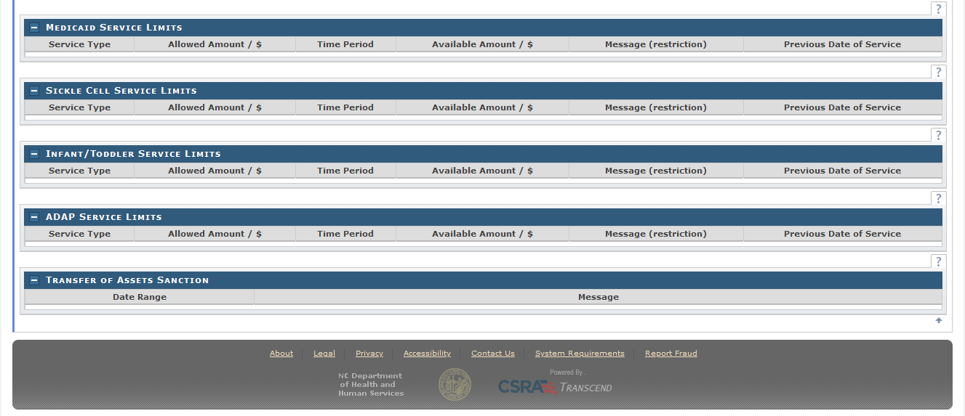
Exhibit 8-4. Provider Eligibility Response Screen (3 of 3)
Section | Description
13 | Medicaid Service Limits displays information about the recipient's service limits. This section contains Service Type, Allowed Amount/$, Time Period, Available Amount, Message (restriction), and Previous Date of Service.
14 | Sickle Cell Service Limits displays information about Sickle Cell service limits. This section contains Service Type, Allowed Amount/$, Time Period, Available Amount, Message (restriction), and Previous Date of Service.
15 | Infant/Toddler Service Limits displays information about Infant/Toddler service limits. This section contains Service Type, Allowed Amount/$, Time Period, Available Amount, Message (restriction), and Previous Date of Service.
16 | ADAP Service Limits displays information about AIDS Drug Assistance Program (ADAP) service limits. This section contains Service Type, Allowed Amount/$, Time Period, Available Amount, Message (restriction), and Previous Date of Service.
17 | Transfer of Assets Sanction displays information about asset transfers for the recipient. This section contains Date Range and Message.

9. Prior Approval
Prior approval (PA) for Medicaid may be required for some services, products, or procedures. PA establishes compliance with clinical coverage policy or program criteria. This basic medical necessity determination is based on the documentation submitted by the provider. If PA is required, it must be obtained before rendering a service, product, or procedure. Obtaining PA does not guarantee payment, ensure beneficiary eligibility on the DOS, or guarantee a post-payment review to verify that the service was appropriate and medically necessary. A beneficiary must be eligible for Medicaid coverage on the date the procedure is performed or the service rendered.
PA for Public Health is required for all services but may be requested up to 365 days after the service is rendered. Providers are able to create and submit most PA requests with attachments as electronic documents, as required, via the Provider Portal. Providers also have the ability to determine if a specific service or procedure requires PA.
NCTracks continues to support the processing of paper PA forms. Providers submitting paper PA forms are still able to check the status of any PA request via the Provider Portal after the paper document has been scanned, imaged, and indexed for document control and tracking purposes.

9.1 General Requests for Prior Approval
PA forms are used to assist in the review of medical necessity for requested services. Providers submitting PA requests in writing are strongly encouraged to use forms published by the service-specific Utilization Review (UR) contractor. However, UR contractors consider all relevant information that is submitted, regardless of whether it is included on a particular form. To access PA forms, contact the service-specific UR contractor.
All PA requests can be submitted electronically via the Provider Portal, including FL2, Hospice Reporting, Transplant, and Visual Aid PA requests. The Provider Portal is designed with drop-down menus wherever possible so the user can select the entry, thus reducing errors and delays from additional information requests. In addition, the request is immediately placed in the queue for review.
- The Provider Portal allows users to view real-time status of PA requests regardless of which vendor made the decision. Denial letters with appeal rights are sent when applicable.
- The system is designed to allow for many of the drug classes that require PA to be automatically approved by the system. The user receives a PA number and the status of the request.
- All DHB Medical (Medicaid/NCHC) PA requests (DME, Visual Aid, Hearing Aid, Surgery, etc.) are required to have a taxonomy code and location for the requesting, billing, and rendering providers. The system validates the taxonomy code against what is on the provider file for that service location and determines if the taxonomy code is valid for the service requested. Providers are strongly encouraged to use the NCTracks Provider Portal to submit PA requests. Manual processing requirements for the old forms are likely to cause delays.
- AVRS inquiry has been replaced with web-based inquiry. Much of the functionality needed to find a PA record in the AVRS has been removed, and replaced by more robust functionality in the Provider Portal. In addition, Dental Benefit Limitations and Refraction Confirmation can be performed in the Provider Portal.
- Once a PA has been issued, it must be used within the time limit specified by the PA OR within 365 days, whichever time period is less.
Providers are encouraged to review their Clinical Coverage Policies and criteria to determine whether PA is required for a specific service/drug/device and, if so, what guidelines apply.
Providers may also find more information on the NC DHHS PA webpage.

10. Submitting Electronic Claims

10.1 Billing Claims Electronically
The NCTracks interactive claim submission system is an electronic version of the Professional (CMS-1500/837P), Institutional (UB-04/837I), and Dental (ADA 2019/837D) Claims Forms. Claims are submitted in real time, which means the user receives an immediate status notification of the claim (to-be-paid, to-be-denied, or pending). The advantages of the NCTracks claims processing system are:
- Provides a secure-access, browser-based application for providers to enter claims transactions.
- Returns an immediate status notification of the claim on-screen.
- Improves the accuracy, timeliness, and availability of information through an easy-to-use point-and-click interface.

10.1.1 Time Limits for Filing Claims
All Medicaid claims, except hospital inpatient and nursing facility claims, must be received by NCTracks within 365 days of the DOS in order to be accepted for processing and payment.
All Medicaid hospital inpatient and nursing facility claims must be received within 365 days of the last DOS on the claim. If a claim was filed within the 365-day time period, providers have 18 months from the last Remittance Statement date to refile the claim.

10.1.2 Billing Professional (CMS-1500/837P) Claims
The following are examples of provider types that submit professional claims:
Allopathic & Osteopathic physicians
Ambulance providers
Ambulatory surgery centers
Certified registered nurse anesthetists
Children’s Development Services Agencies
Chiropractors
Clinical pharmacist practitioners
Community Alternatives Program services
Critical Access Behavioral Health Agencies
Dietary & Nutritional Services
Direct-enrolled independent behavioral health practitioners
DME suppliers
Federally qualified health centers
Free-standing birthing centers
Health departments
Hearing aid dealers
HIV case management services
Home infusion therapy services
Independent diagnostic testing facilities
Independent laboratories
Independent practitioners
Local education agencies
Local Management Entities
Maternity Care Coordination/Child Services Coordination services
Non-Emergency Medical Transportation (NEMT) providers
Nurse midwives
Nurse practitioners
Ophthalmologists
Optical supply dealers
Optometrists
Orthotics and prosthetics suppliers
Outpatient behavioral health services provided by Community Intervention Services Agencies
Personal care services
Physicians
Planned Parenthood (non-medical doctor) organization
Podiatrists
Portable X-ray services
Private duty nursing services
Rural health clinics

10.1.2.1 Creating a Professional Claim in NCTracks
Note: The following instructions are available in the most up-to-date form in SkillPort under the title CLM 221 Submitting a Professional Claim Participant User Guide.
1
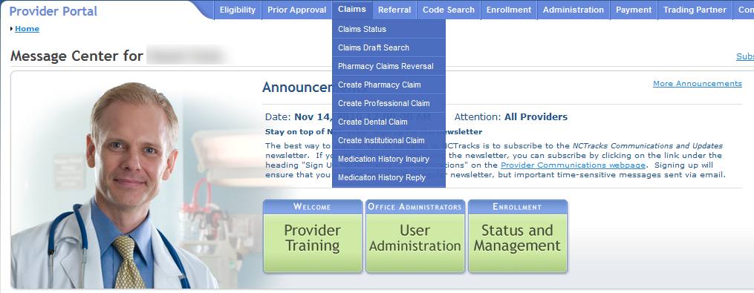
2
Exhibit 10-1. Creating a Professional Claim
Step | Action
1 | Hover over the Claims menu.
2 | Select Create Professional Claim. The Verify Patient screen displays.

10.1.3 Billing Institutional (UB-04/837I) Claims
The following provider types submit Institutional claims:
- Ambulance services
- Critical Access Behavioral Health Agencies
- Dialysis facilities
- Home health agencies
- Hospice services
- Hospitals
- Inpatient behavioral health services provided by Community Intervention Services Agencies
- Intermediate care facilities for individuals with intellectual disability
- Nursing facilities
- Psychiatric residential treatment facilities
- Residential child care (Level II, III, and IV) facilities

10.1.3.1 Creating an Institutional Claim in NCTracks
Note: These instructions are available in the most up-to-date form in SkillPort under the title CLM 241 Submitting an Institutional Claim Participant User Guide.
2
1
Exhibit 10-2. Creating an Institutional Claim
Step | Action
1 | Hover over the Claims menu.
2 | Select Create Institutional Claim. The Verify Patient screen displays.

The Claim Information tab on the Create Institutional Claim screen allows users to enter general information about an institutional claim. This webpage contains a number of collapsible/expandable sections. Normal default behavior displays the sections collapsed. Sections expand or collapse when providers select Yes or No for entering information for the sections.

10.1.4 Billing Dental (ADA 2019/837D) Claims
The following provider types submit Dental claims:
- Dentist
- Orthodontist
- Federally qualified health center (dental services only)
- Health department dental clinic (dental services only)
- Rural health clinic (dental services only)

10.1.4.1 Creating a Dental Claim in NCTracks
Note: These instructions are available in the most up-to-date form in SkillPort under the title CLM321 Submitting a Dental/Orthodontic Claim Participant User Guide.
1
2
Exhibit 10-3. Creating a Dental Claim
Step | Action
1 | Hover over the Claims menu.
2 | Select Create Dental Claim.

10.1.5 Creating a Pharmacy Claim in NCTracks
Note: These instructions are available in the most up-to-date form in SkillPort under the title CLM 231 Submitting a Pharmacy Claim Participant User Guide.
1
2
Exhibit 10-4. Creating a Pharmacy Claim
Step | Action
1 | Hover over the Claims menu.
2 | Select Create Pharmacy Claim. The Verify Patient screen displays.

10.1.6 Creating a Pharmacy Claim Reversal in NCTracks
Note: These instructions are available in the most up-to-date form in SkillPort under the title CLM 231 Submitting a Pharmacy Claim Participant User Guide.
A pharmacy claim reversal is used to reverse a claim previously entered in NCTracks. To reverse a claim, the provider needs to know the claim pharmacy’s NPI number and the Prescription Number, National Drug Code (NDC), and Date Dispensed.
1
2
Exhibit 10-5. Creating a Pharmacy Claim Reversal
Step | Action
1 | Hover over the Claims menu.
2 | Select Pharmacy Claims Reversal. The Create Pharmacy Reversal screen displays.

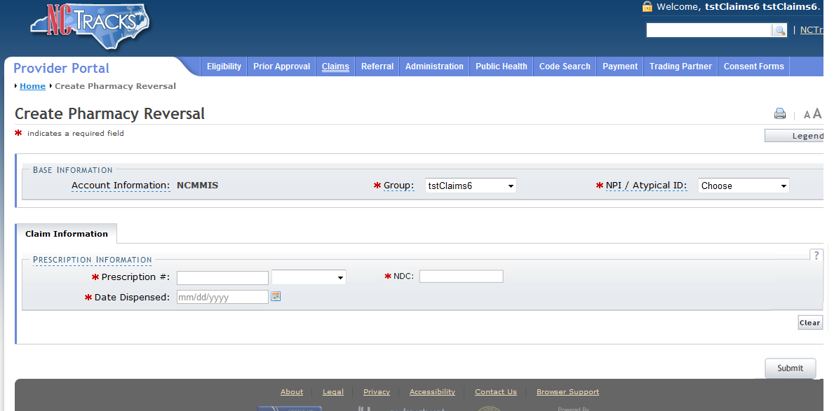
3
5
4
2
1
Exhibit 10-6. Create Pharmacy Reversal Screen
Step | Action
1 | NPI/Atypical ID: Select the Pharmacy NPI #.
2 | Prescription #: 123456789
3 | National Drug Code: 00186502082 – NEXIUM DR 20 MG CAPSULE
4 | Date Dispensed: 2/11/2021.
5 | Select the Submit button.

10.1.7 Submitting Payments from Other Payers and Line Items
The Other Payers screen allows the user to enter information for third-party payers on a claim. When Yes is selected for the question “Would you like to add All Other Payers?”, the All Other Payers section expands. If third-party insurance policies are in effect, payments made by those policies must be reflected here. The All Other Payers section has three required fields: Name, Date Paid, and Paid Amount. Other Payer Medicare and/or private insurance details should be populated at the detail line level.
If applicable, the user can add more than one payer by selecting the Add button. The Clear button clears the current entry information. To delete a payer, select the Remove Service Line button in the last column. Exhibit 10-7 shows how All Other Payer line item and Editing Row #1 details are added. In this example, there are no other payers assigned. Selecting No for the question “Would you like to add All Other Payers?” collapses the All Other Payers section. Selecting the Next button advances to the Service(s) screen. Please note that all fields marked with an asterisk (*) are required.
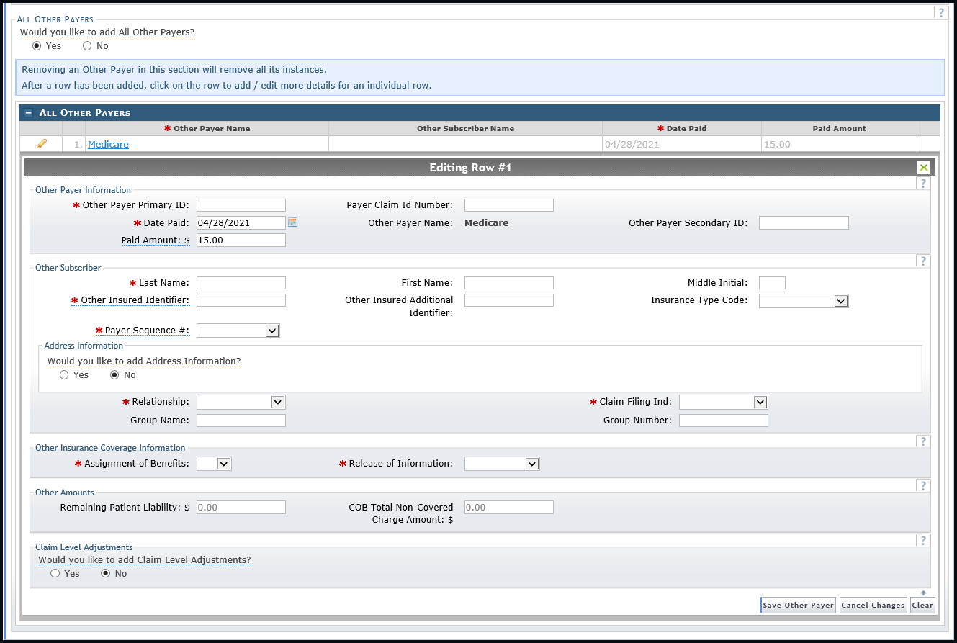
3
4
2
1
5
4
Exhibit 10-7. Other Payers Screen
Step | Action
1 | Would you like to add All Other Payers?: Select Yes. The All Other Payers section expands.
2 | Other Payer Name: Medicare (Other Payer Medicare and/or private insurance details should be populated at the detail line level).
3 | Complete Editing Row #1.
4 | Complete all fields marked with an asterisk (*).
5 | Select the Save Other Payer button.

Note: These instructions are available in the most up-to-date form in the Participant User Guide for the corresponding claim type in SkillPort.

10.1.8 Transmitting Attachments and Submitting the Claim
The provider may want to add attachments to a claim such as Admittance Summary, Certifications, Diagnosis Report, Discharge Summary, Explanation of Benefits (EOB), physician’s orders, etc. (these are examples and are not applicable to all claims). The provider can enter up to nine attachments.
After selecting the Attachment Type, use Transmission Codes to represent the method of delivery: Electronic, E-mail, File Transfer, Mail, or On Request.
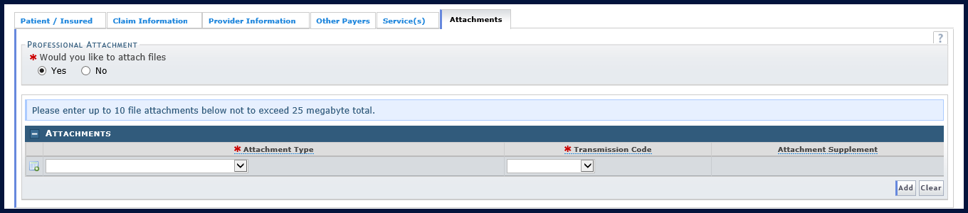
4
1
2
3
Exhibit 10-8. Attachments Screen
Step | Action
1 | Would you like to attach files?: Select Yes. The Attachments section expands.
2 | Select the attachment type from the Attachment Type drop-down list.
3 | Select the method of delivery from the Transmission Code drop-down list:  - Select Electronic (the preferred method) to electronically attach the documents. Selecting this option allows the provider to browse to his/her desktop for the documents and attach them.  - Select Mail to mail the documents. When this option is selected, the mailing address to be used will populate in the Attachment Supplement column.  - Select On Req if the provider plans to make the supplemental information available upon request.
4 | Would you like to attach files?: Select No (to collapse the Attachments section).

Note: These instructions are available in the most up-to-date form in the Participant User Guide for the corresponding claim type in SkillPort. Refer also to the How to Add an Attachment to a Claim Job Aid.

10.1.8.1 Submitting the Completed Claim
The Submit option becomes available once the Attachments page is active. If the user selects the Submit button and any errors are found, an Error Summary dialog displays. Correct the errors and select Submit again to resubmit the claim.
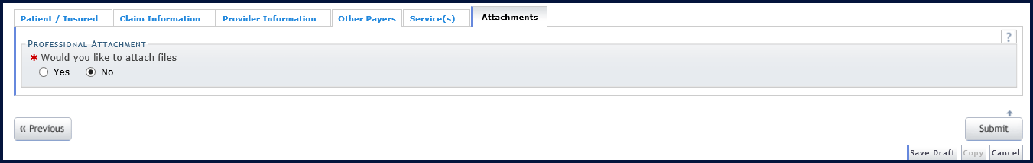
2
1
Exhibit 10-9. Submit Claim
Step | Action
1 | Would you like to attach files?: Select the No radio button.
2 | Select the Submit button.

Note: These instructions are available in the most up-to-date form in the Participant User Guide for the corresponding claim type in SkillPort.

10.2 NC Medicaid Implementation of the National Correct Coding Initiative
The Patient Protection and Affordable Care Act [(H.R. 3590) Section 65607 (Mandatory State Use of National Correct Coding Initiative [NCCI])] requires state Medicaid programs to incorporate NCCI methodologies into their claims processing systems. The purpose of the NCCI edits is to prevent improper payments when incorrect code combinations are reported.
The two components of NCCI are procedure-to-procedure (PTP) edits and medically unlikely edits (MUE).
- CCI PTP edits are for practitioners, ambulatory surgical centers, and outpatient hospital services (only for drugs, high-tech images, ultrasounds, and labs as they are billed at a Current Procedural Terminology (CPT)/HCPCS code level).These edits define pairs of HCPCS/CPT codes that should not be reported together.
- MUE edits are units of service edits for practitioners, ambulatory surgical centers, outpatient hospital service (only for drugs, high-tech images, ultrasounds, and labs as they are billed at a CPT/HCPCS code level), and DME. This component defines for each HCPCS/CPT code the number of units of service that is unlikely to be correct (e.g., claims for excision of more than one appendix or more than one hysterectomy).
NCCI edits are updated quarterly. For more information on NCCI, refer to the DHB website at https://medicaid.ncdhhs.gov/documents/ncci-additional-information. Refer also to the Understanding NCCI Edits Job Aid located under the Claims Submission section on the NCTracks User Guides & Fact Sheets page.
Providers are reminded that:
- Services must be reported correctly.
- Multiple HCPCS/CPT codes should not be reported when a single comprehensive HCPCS/CPT code is used.
- Code describes these services.
- A procedure should not be fragmented into component parts.
- A bilateral procedure code should not be unbundled into two unilateral procedure codes.
- Down coding and up coding should be avoided.

10.2.1 Additional Correct Coding Edits Implementation
DHB has implemented correct coding guidelines and edits nationally sourced by organizations such as CMS and the American Medical Association (AMA). These edits identify any inconsistencies with CPT, AMA, CMS, and/or DHB policies and deny the claim line.
For example, the edits ensure that:
- The appropriate procedure code is utilized based on age and gender of the patient.
- If a procedure code is submitted that requires a primary procedure code, DHB verifies that the primary procedure code has been submitted.
- Procedure codes are billed in the appropriate place of service as defined by AMA and/or CMS; for example, certain procedure codes are not permitted to be performed outside of an inpatient setting.
- Obstetric services including antepartum care, delivery, and postpartum care are billed appropriately according to CMS guidelines and DHB policy.
- The appropriate Evaluation and Management (E&M) codes are utilized for new patients and established patients.
- Certain services related to surgical procedures are included in the payment of the global surgery package; these services include E&M and related surgical procedures performed by the same physician for the same patient.
- Duplicate services are not submitted for the same provider, same patient for the same DOS.

10.3 Trading Partner Agreements
A Trading Partner Agreement (TPA), defined in 45 CFR 160.163 of the transaction and code set rule, is a contract between parties who have chosen to exchange information electronically. The TPA stipulates the general terms and conditions by which the partners agree to exchange information electronically. The document defines participant roles, communication, and privacy and security requirements, and identifies the electronic documents to be exchanged. TPAs are used by all entities that wish to establish an electronic relationship with the NC DHHS programs supported by NCTracks. TPAs must be on file prior to testing electronic transactions with NCTracks.
An EDI Trading Partner is any entity (provider, billing service, software vendor, employer group, financial institution, clearinghouse, etc.) that transmits electronic data to, or receives electronic data from, another entity.
Trading partner registration, which includes electronic signature of the TPA and generation of the Transaction Supplier Number (TSN), is an online process. Clearinghouses, service bureaus, Trading Partners, billing agents, and other entities that intend to exchange electronic transactions with NCTracks must sign the TPA and be enrolled into NCTracks. Providers who are not enrolled in NCTracks cannot enroll as Trading Partners until they have been registered and credentialed with NCTracks. Visit https://www.nctracks.nc.gov/content/public/providers/provider-enrollment.html for more information.
The NCTracks website contains links to all forms and related information for enrollment as a Trading Partner. Refer to https://www.nctracks.nc.gov/content/public/providers/provider-trading-partners.html for additional information and a variety of useful quick links such as Frequently Asked Questions (FAQs), enrollment instructions, and NCTracks HIPAA Companion Guides.
Note that all entities should obtain an NCID before enrolling into NCTracks.
NCID Registration: https://ncid.nc.gov. Contact information and instructions for enrolling as a NCTracks Trading Partner, obtaining technical assistance, initiating and maintaining connectivity, sending and receiving files, testing, and other related information is listed below.
NCTracks Support Services Contact Information
Phone: 1-800-688-6696
E-mail: NCTracksprovider@nctracks.com
Website: https://www.nctracks.nc.gov/content/public/providers.html
EDI Technical Assistance
Phone: 1-800-688-6696
E-mail: NCMMIS_EDI_Support@csra.com
Website: http://www.nctracks.nc.gov/provider/index.html
Companion Guides: https://www.nctracks.nc.gov/content/public/providers/provider-trading-partners.html
Provider/Trading Partner Enrollment
Phone: 1-800-688-6696
E-mail: NCTracksprovider@nctracks.com
https://www.nctracks.nc.gov/content/public/providers/provider-enrollment.html

Note: Detailed data specifications are published separately by the industry committees responsible for their creation and maintenance.

10.4 Billing with Software Obtained from a Contractor
A variety of software programs that provide integrated health insurance billing are available. Providers must obtain software from a contractor who has written the software using specifications adopted under HIPAA.
After verifying that the contractor has tested their software with NCTracks, the provider must complete a TPA located on the DHB website at https://medicaid.ncdhhs.gov/medicaid/your-rights. Once the TPA is processed, providers may begin billing immediately.

10.5 Billing with Software Written by Provider’s Office or Company
Facilities and providers may develop their own software for electronic claims filing. This software must comply with the electronic standards as adopted under HIPAA. HIPAA Transaction Implementation Guides may be obtained from Washington Publishing Company at www.wpc-edi.com. In addition, NC Medicaid Companion Guides, designed for use in conjunction with HIPAA Transaction Implementation Guides, may be found at https://www.nctracks.nc.gov/content/public/providers/provider-trading-partners.html.

11. Claim Forms and Resolution
All claims may be submitted either electronically via the NCTracks Secure Provider Portal or as paper forms submitted via mail. However, for the most efficient processing, providers are encouraged to submit claims electronically. Submitting claims via the portal or X12 allows them to be processed more quickly and accurately and allows instant status tracking in real time.

11.1 Pharmacy Claims
All pharmacy claims may be submitted electronically including DPH pharmacy claims. Providers may also submit pharmacy claims directly to NCTracks via the Provider Portal if preferred, although POS transmissions are the most efficient method for pharmacy claim submissions.

11.2 Processing Claims Without a Signature
Providers who file claims electronically are not required to provide a signature. Providers must provide an original signature for paper claims.
Forms that must be signed must contain the provider’s original signature; stamped signatures are not accepted. Providers are encouraged to review the current Clinical Coverage Policy that applies to them for other specific requirements.

11.3 Time Limit Overrides
Since DHB and NCTracks must follow all federal regulations to override the billing time limit, requests for time limit overrides must document that the original was submitted within the initial 365-day time period. Providers are encouraged to submit time limit override requests electronically for the most efficient processing. Examples of acceptable documentation for time limit overrides include:
- Dated correspondence from DHB or NCTracks about the specific claim received that is within 365 days of the DOS.
- An explanation of Medicare benefits or other third-party insurance benefits dated within 180 days from the date of Medicare or other third-party payment or denial.
- A copy of the Remittance Statement showing that the claim is pending or denied; the denial must be for reasons other than time limit.
The billing date on the claim or a copy of an office ledger is not acceptable documentation. The date that the claim was submitted does not verify that the claim was received by NCTracks within the 365-day time limit. Providers may also submit via the batch claims process and use the EOB cover sheet as an attachment.
A delay reason code must be used and attachments must be provided when submitting an electronic timely filing override. Providers should use delay reason code 7 if they are requesting an override based on delay of processing from another payer, or delay reason code 9 if they are requesting an override based on documentation from an NCTracks Remittance Statement and a rejected/denied claim.
Providers must also keep the claim timely (active) within 18 months of the last denied claim (unless the last claim denied for time limit, in which case it cannot be overridden), or within 180 days of receiving an EOB from Medicare or another payer.
For instructions for submitting time limit overrides, refer to the Job Aid “How to Submit Claim Adjustments and Time Limit and Medicare Overrides ” located under the Claims Submission section on the NCTracks User Guides & Fact Sheets page.
If the claim is a crossover from Medicare or any other third-party commercial insurance, regardless of the DOS on the claim, the provider has 180 days from the EOB date listed on the EOB from that insurance (whether the claim was paid or denied) to file the claim to Medicaid. The claim should be submitted electronically, and a copy of the third-party or Medicare EOB can be uploaded as an attachment through the Provider Portal.

12. Claim Details and Options Post-Submittal

12.1 Transaction Control Number (TCN)
The TCN is the 16-character claim control identifier auto-assigned in NCTracks. The TCN consists of the following data: date the claim enters adjudication, sequential batch number, line number reference for separated or split claim, and adjustment code.
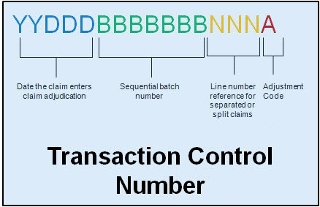
Exhibit 12-1. Transaction Control Number

12.2 Causes for Adjustments
Providers may submit claims electronically using the X12 837 transaction or from the NCTracks Provider Portal for Professional, Institutional, and Dental claims. Pharmacy claims can be submitted through the Provider Portal or electronically using National Council for Prescription Drug Programs (NCPDP) format. With the requirement to accept electronic attachments, the need for providers to submit paper is greatly reduced. Therefore, when providers find they need to submit an adjustment to void or replace a previously paid claim, they may use the 837 or the Provider Portal to submit the adjustment and include any attachments electronically.
Other scenarios where an adjustment may be automatically initiated by the system include retro-eligibility for Medicaid. Mass Adjustments support the Fiscal Agent’s (FA’s) ability to perform adjustments on a mass selection of claims, e.g., a rate change to a procedure that is applied retroactively. The claim criteria are entered in the adjustment request where the claims are selected and set up for adjustment processing. The mass adjustments workflow supports batch processing of adjustment requests or real-time processing to accommodate situations where the FA must perform a provider-initiated adjustment on behalf of the provider.

12.3 Claim Status and Claim Copy
The NCTracks Provider Portal allows providers to search for the status of a claim and copy the claim details to a new claim, allowing for the resubmission of the claim. This process is the same for all claim types.
The Claim Status Request screen is used to search for the status of a claim. To display this screen, select the Claims Status option from the Claims menu in the NCTracks Provider Portal. The Claim Status Request screen has three sections: Base Information, Claim Search, and Claims (Results). The required fields are Dates of Service (From and To) and Recipient ID. Use more search fields to return a quicker and more accurate response. All required fields are denoted by a red asterisk (*).
Note: These instructions are available in the most up-to-date form in SkillPort.
Exhibit 12-2. Claims Status Menu Option
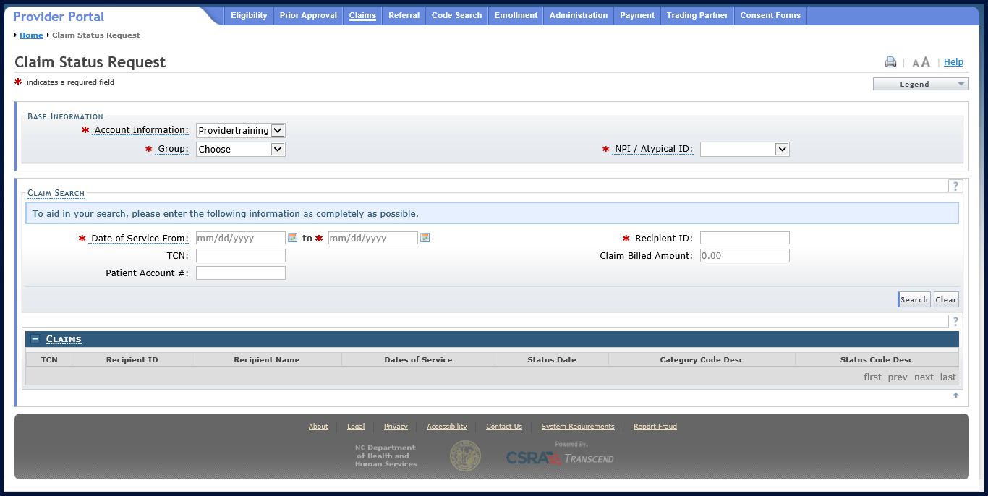
Exhibit 12-3. Claim Status Request Screen
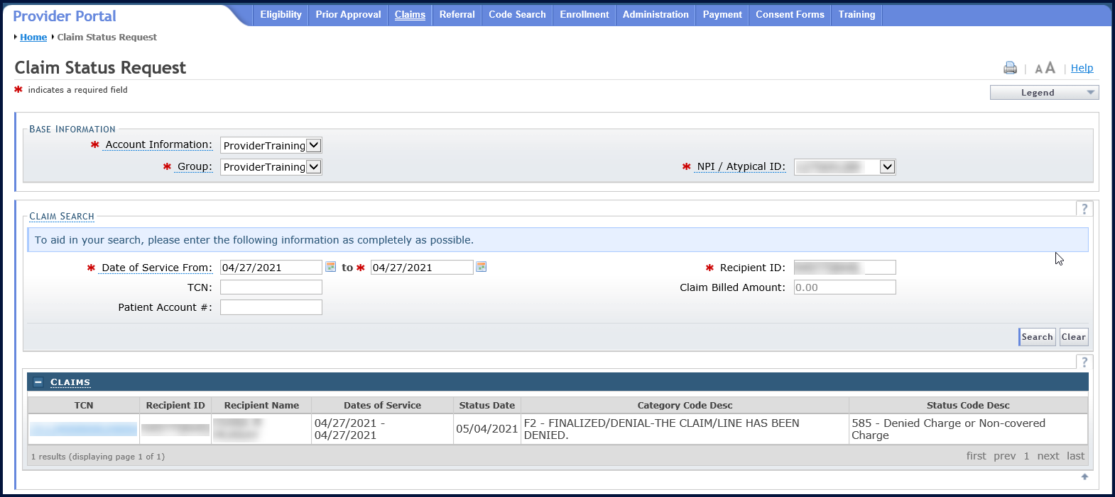
Exhibit 12-4. Claim Status Request Result

12.4 Resubmitting a Claim Through the Provider Portal
The claim resubmission process starts with the provider searching for the original claim that was previously adjudicated. If the original claim resulted in a denial, the provider can submit a new claim using the original claim. A denied claim cannot be used to submit an adjustment. Only paid original claims are eligible for adjustments.
The provider has the option to enter a claim completely from scratch, with the adjustment indicators noted in the Claim Frequency Type Code and Original Claim Reference Number.
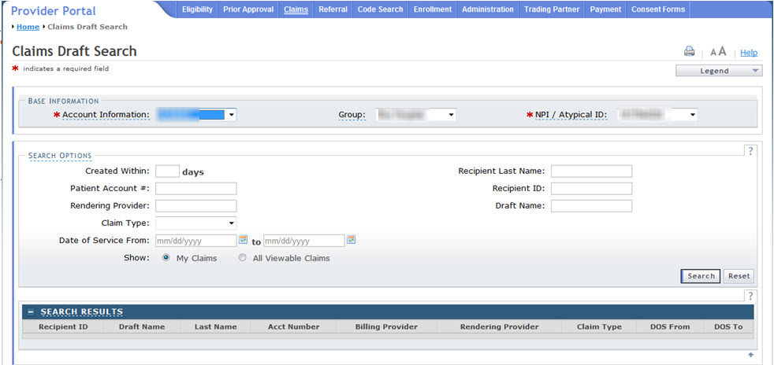
Exhibit 12-5. Claims Draft Search Screen

12.4.1 Claim Information Tab on Create Claim Screen
The provider updates the Claim Frequency Type Code to 7-Replace-PC or 8-Void-PC, and adds the original claim number to the Original Claim Ref # field. This information triggers adjustment processing.
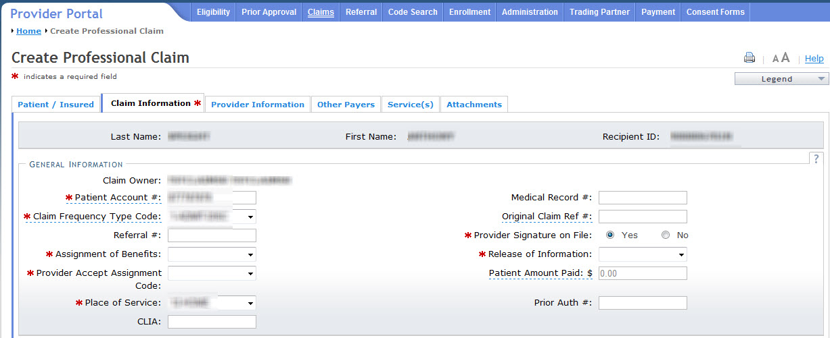
Exhibit 12-6. Claim Information Tab

12.4.2 Attachments Tab on Create Claim Screen
Often, the need for adjustments includes the request for attachments. The provider has the ability to include any appropriate attachments to support the adjustment.
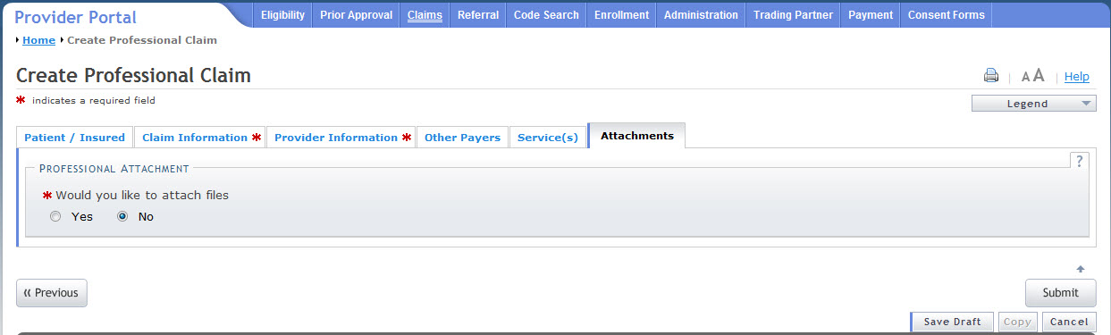
Exhibit 12-7. Create Professional Claim Screen for Submit

12.5 Health Check Claim Details
Health Check claim details are reported on the Professional Claims Layout section of the Remittance Statement. Procedure Code, Description, Total Units, Total Billed, Total Allowed, Paid amounts, and EOB code are reported in the Professional Claim section of the Remittance Statement.
There is a separate Remittance Statement section for Health Check fees, which includes:
- Dates of Service
- Rate Cohort code and description
- Number of Claims
- Paid Amount
For changes and updates to coverage criteria, billing information, and other program requirements, refer to the NC Medicaid general and special bulletins links under Quick Links in NCTracks.
https://www.nctracks.nc.gov/content/public/providers/provider-communications.html

This Page Intentionally Left Blank

13. Resolving Denied Claims
EOBs are codes used by Medicaid/NCHC to explain how a claim processed and sometimes provide action that needs to be taken to correct a claim. They are found on the Remittance Statement. The following are commonly received EOBs, their descriptions, and suggested resolutions. Although the suggested resolutions are for common denial cases, each claim may present a unique processing scenario. For further information or claim research, contact NCTracks for claim-specific analysis.
Edit | EOB | EOB Description | Possible Resolution
00259 | 00094 | An insurance primary to Medicaid is suspected. Please resubmit with primary insurance information documented on the Medicaid claim. | Bill charges to primary insurance prior to billing Medicaid.
00358 | 05203 | Service represented by this procedure code/modifier combination is not covered as billed. | This is a non-covered service as billed; please review combination of procedure code and modifier.
00431 | 02310 | Procedure code is not covered or not on file for dates of service. | This is a non-covered procedure on the date of service.
00433 | 02312 | Revenue code is not covered for dates of service. | This is non-covered on the date of service.
00701 | 04701 | Missing billing taxonomy code. | No taxonomy submitted for the billing provider.
01100 | 01723 | Drug not on PDL. Pharmacy PA required. | Obtain PA when billing for this drug.
01162 | 07062 | Dispense brand name drug. Generic drug is non-preferred. | Dispense brand name drug.
01760 | 01760 | Claim indicates Medicare is prior payer but no Medicare allowable amount is indicated for this detail. | Please include Medicare payment information on claim.
02601 | 02601 | Procedure not covered under the Family Planning Waiver. | This is a non-covered service for waiver program.
04531 | 04531 | Billing provider taxonomy is invalid for service location. | Correct the taxonomy code and resubmit the claim if necessary.
07011 | 03102 | The taxonomy code for the billing provider is missing or invalid. | Provider submitting taxonomy code not appropriate for claim being billed.
07012 | 03100 | The taxonomy code for the rendering provider is missing or invalid. | Correct or add the taxonomy code and resubmit the claim if necessary.
07013 | 03101 | The taxonomy code for the attending provider is missing or invalid. | Correct or add the taxonomy code and resubmit the claim if necessary.
08599 | 08599 | The benefit plan is not matching provider or beneficiary eligibility or the service covered. | Verify the provider is appropriate for the recipient’s benefit plan and resubmit the claim if necessary.
09932 | 00905 | Drug not covered under rebate agreement. | Submit a drug covered under a rebate agreement.
09933 | 00009 | Service not covered by the Medicaid program; pharmacy: see non-covered items under scope of services in manual. | Submit a drug covered by the beneficiary’s benefit plan.
13630 | 00498 | Exact duplicate-same provider/procedure/billed amount/date of service, dental. | This claim was duplicate of prior claim. Informational.
34410 | 05400 | Exact duplicate-same Rend Prov/PCode/Internal Modifier/DOS/Mod/Bill Amt/different TCN. | This claim was duplicate of prior claim. Informational.
49560 | 02492 | Drug dispensed is a therapeutic duplication of prior claim. | Submit an appropriate DUR response.
49570 | 02493 | Drug dispensed is an early refill (overuse alert). | Submit an appropriate DUR response or resubmit when the refill is no longer early.

13.1 CCI/MUE Denials
EOBs have been created to indicate a claim that was denied for a CCI/MUE or other National Correct Coding Initiative (NCCI) edit. Providers have the ability to view the denials via the North Carolina Electronic Claims Submission (NCECS) Web Tool, which provides a detailed explanation of why an edit was invoked and the supporting industry (CMS, AMA, etc.) standards justifying the denial.
Providers must determine if the denied claim can be resubmitted to Medicaid for reconsideration by accessing the following link from the CMS website: https://www.medicaid.gov/medicaid/program-integrity/ncci/index.html.
By selecting the code, the provider can determine based on the modifier column how the CCI denial may be resolved.
If the NCCI edit responsible for a CCI denial has a modifier indicator of ‘1’, the provider can make modifications to the previously submitted claim by submitting a new day claim with an appropriate modifier appended to the procedure code.
If the NCCI edit responsible for a CCI denial has a modifier indicator of ‘0’, the claim cannot be corrected and resubmitted as a new day claim. Refer to Section 3.1.2, Appealing a CCI/MUE Denial for additional information.
Modifier Indicator | Definition
‘0’ – Not Allowed | There are no modifiers associated with NCCI that are allowed to be used with this code pair; there are no circumstances in which both procedures of the code pair should be paid for the same beneficiary on the same day by the same provider.
‘1’ – Allowed | The modifiers associated with NCCI are allowed with this code pair when appropriate.

13.1.1 MUE Denials
Providers must determine the allowed units of service by viewing the appropriate MUE table from the CMS website at https://www.cms.gov/Medicare/Coding/NationalCorrectCodInitEd/MUE.html
If the claim is denied because the billed units of service exceed the allowed units, the provider can make modifications in the previously submitted claim by submitting a new day claim with the corrected units of service. If the provider feels that the exceeded units of service are medically reasonable, the denial may be appealed.

13.1.2 Appealing a CCI/MUE Denial
Providers may submit a letter requesting reconsideration of a CCI/MUE denial to DHB at the address listed below. The request must include documentation supporting medical necessity.
Division of Health Benefits
Appeals Unit
Clinical Policy and Programs
2501 Mail Service Center
Raleigh, NC 27699-2501
Requesting a reconsideration of a CCI/MUE denial is not equivalent to the adjustment process.

13.2 Provider Claims Denial Reconsideration Reviews
Providers are encouraged to exhaust all claim corrective measures before requesting an appeal. After all other avenues have been pursued, if necessary, providers may initiate an appeal. The purpose of the regulations contained in 10A NCAC 22J .0101-.0104 is to specify the rights of providers to appeal reimbursement rates, payment denials, disallowances, payment adjustments and cost settlement disallowances and adjustments.
The process to appeal a claims denial is summarized below. Please note that provider appeals for actions taken by program integrity and appeals about reimbursement rates, disallowances, payment adjustments and cost settlement disallowances and adjustments are excluded from the process below. These actions should be appealed to the DHHS Hearing Office and the DHB Finance Management Section, respectively.
- A provider may request a reconsideration review within 30 calendar days from receipt of final notification of payment, payment denial, disallowances, payment adjustment, notice of program reimbursement and adjustments and within 60 calendar days from receipt of notice of an institutional reimbursement rate. Final notification of payment, payment denial, disallowances, and payment adjustment means that all administrative actions necessary to have a claim paid correctly have been taken by the provider and DHB or the fiscal agent has issued a final adjudication.
- If no request is received within the respective 30- or 60-day periods, the State agency's action shall become final.
- A request for reconsideration review must be in writing, signed by the provider, and contain the provider's name, address, provider number, and telephone number. The request must state the specific dissatisfaction with the DHB action and explain all efforts made to have the claim(s) pay. Additionally, the redacted Remittance Statement showing the claim denial, medical records, and any other information the provider wishes to submit to support medical necessity for the service or that the claim denied incorrectly should be submitted with the provider claims denial reconsideration review request.
- Reconsideration review requests should be mailed to Appeals Unit, Clinical Policy and Programs, DHB at the DHB address (listed in Section 13.1.2).
- Following the review, DHB shall render a decision in writing and send it by certified mail to the provider. The decision shall be made within 30 calendar days or such additional time thereafter as specified in writing during the 30-day period.
- If the provider disagrees with the reconsideration review decision, he may request a contested case hearing at the Office of Administrative Hearings in accordance with 10A NCAC 01.
- Once a final overpayment or final erroneous payment is determined to exist by DHB, action is taken immediately to recover such overpayment or erroneous payment. If the provider's appeal is successful, repayment is made to the provider.

This Page Intentionally Left Blank

14. Remittance Statement
The Remittance Statement (also referred to as Remittance Advice [RA] or Remittance and Status Report) is a computer-generated document showing the status of all claims submitted through NCTracks, along with a detailed breakdown of payment. The Remittance Statement contains information necessary for providers to resolve any issues concerning the adjudication and payment of their claims.
Providers have access to electronic views of their Remittance Statements via the NCTracks Secure Provider Portal. Providers are also able to inquire online regarding payment status from multiple payers (DHB, DMH/DD/SAS, and DPH).
NCTracks produces Remittance Statements in two formats: (1) PDF version of the paper layouts; or (2) electronic Remittance Statements using the HIPAA approved EDI 835 transaction set. Providers can select their preferred Remittance Statement notification method.
NCTracks generates electronic Remittance Statements via ANSI ASC X12N standards, using the Health Care Payment and Remittance Advice (835) transaction set per HIPAA regulations. For capitation claims, HIPAA mandates that the 820 (Payroll Deducted and Other Group Premium Payment for Insurance Products) transaction set is produced to report those claims. All pended claims are reported separately by including them in the Health Care Payer Unsolicited Claim Status (277U/277P) transaction set.
NCTracks gives the provider access to the Remittance Statements via the following:
- Provider message screen
- E-mail notification
- Report2Web
- Paper form
Remittance Statement notifications are posted to the Provider Portal Message Center Inbox. The provider can select a hyperlink to open an electronic version of the printed Remittance Statement.
When the Remittance Statement and/or notifications are published to the Message Center, an e-mail is also sent to the provider's e-mail account informing them that items have been posted to the Message Center.
Note: These instructions are available in the most up-to-date form in SkillPort under the title PRV574 Using the Provider Message Center.
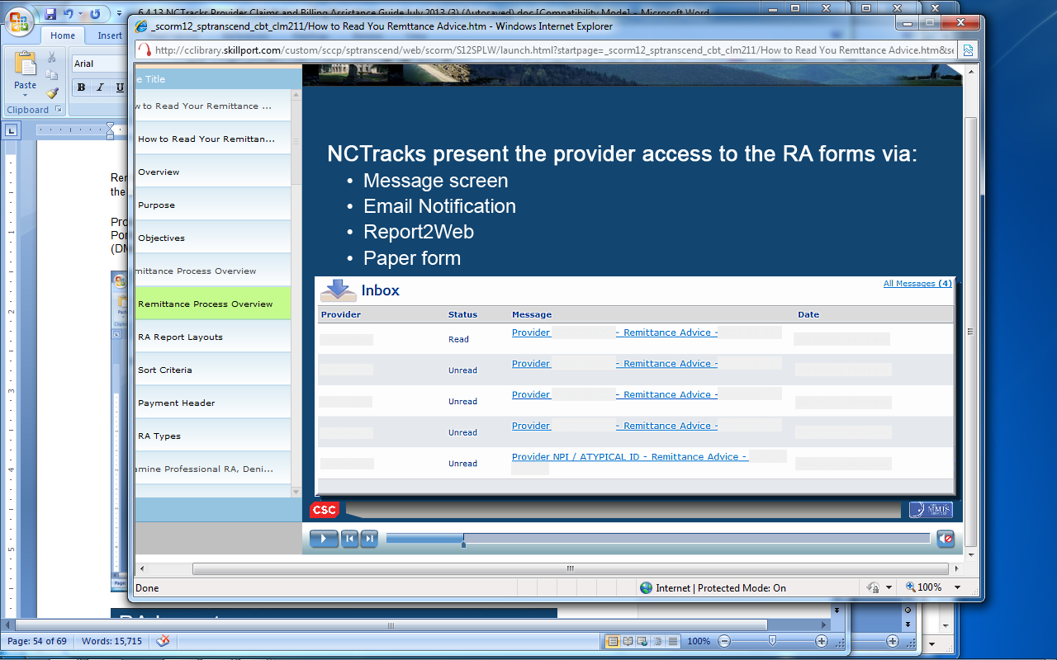
Exhibit 14-1. Provider Message Center Inbox

14.1 Remittance Statement Sections and Subsections
The Remittance Statement is composed of information identified by subject headings. Each major subject heading is further divided into subsections depending on provider type or claim type. All Remittance Statements have the same basic data flow and layout. The Remittance Statements are sorted by the following criteria:
- Claim type
- Professional
- Dental
- Institutional
- Pharmacy
- Claim status
- Claim document type (encounter and FFS claims)
- Recipient Last Name and First Name
Summary totals are reported at the end of:
- All claim types
- Each claim type
- Different claim statuses within the same claim type
- Different claim adjustment type codes within the same claim type
All Remittance Statement types have a Provider Notification page and a Summary Page. All other pages are contingent upon the type of claims activity.

14.1.1 Remittance Statement Layouts
The Professional Remittance Statement broadly characterizes remittance layouts for Practitioner, Medicare Part B Crossover, Clinic, Hearing Aid, Private Duty Nursing Personal Care Services, Independent Laboratory/X-Ray, Mental Health, DME/O&P (Durable Medical Equipment/Orthotics and Prosthetics), Ambulance, Home Infusion Therapy, Services, Professional Capitation, and Optical claims.
The Institutional Remittance Statement contains the remittance layout for Inpatient, Medicare Part A Crossover (inpatient crossover), Long-Term Care, Hospice, Home Health, Institutional Capitation, Residential Health Care, Outpatient, Medicare Part B Crossover UB (outpatient crossover), and Institutional Ambulance claims.
The Dental Remittance Statement contains the remittance layout for Dental claims.
The Pharmacy Remittance Statement contains the remittance layout for Pharmacy claims.

14.1.2 Paper Remittance Layout
The following layouts are used to display the claim and financial transaction information (based on the claim type) on paper remittances:
- Provider Notification
- Provider Summout
- Payment Header
- Professional Remittance
- Dental Remittance
- Institutional Remittance
- Pharmacy Remittance
- Financial Transactions Remittance
- Accounts Receivable Remittance
- Management Fees Remittance

14.1.3 Paid Original Claims Page
The Professional Paid Original Claims page details payments allowed towards the claim.
The top section of the remittance form gives the total details for that claim transaction. Multiple procedures in the claim are separated out by line number.
- Recipient Name
- Recipient ID
- Original TCN
- Transaction Control Number
- Dates Of Service
- Claim Service Begin and End Date
- Days/Units
- Quantity or Units Submitted
- Total Billed
- Claim Charge Amount
- Non Allowed
- Tot Allowed
- PYBLE Cutback charge
- Other Charges
- Paid Amount
- Claim Reimbursement Amount
- HIC (Medicare Health Insurance Claim number)
- Patient Account Number and Medical Record Number
The Pharmacy Paid Original Claims page details payments allowed towards the claim and differs slightly from the Professional, Institutional, and Dental claim types. It adds a prescription (RX) ID and has no need for an end Date of Service, nor does it have sections for Day/Units, Non-Allowed, Payable Cutback, Payable Charges, or Other Charges.

14.1.4 Denied Original Claims Page
The Denied Original Claims page displays the recipient name and ID followed by details as to why a claim was denied. The Remittance Statement may represent several claims designated by their TCNs and shows the Dates of Service, Days/Units, Total Billed, Non Allowed/Total Allowed, Payable Cutback/Payable Charges, Third-Party Liability (TPL) Amount, Other Charges, and Paid Amount. It also provides the Patient Account Number and Medical Record Number.
The top set of numbers gives providers the particulars of the Denied Original Claim. Then it breaks down the claim record per line item (LI), charges allowed or denied, dates of services, applicable charges, and Rendering Provider ID.
The next section designates the following:
- LI number
- Benefit Plan
- Procedure Code Short Description
- Dates of Service
- Total Billed
- NON Allowed
- Allowed
- Line item error details
- EOB code
- Errors code
- Remark code
- Adjustment Reason Code
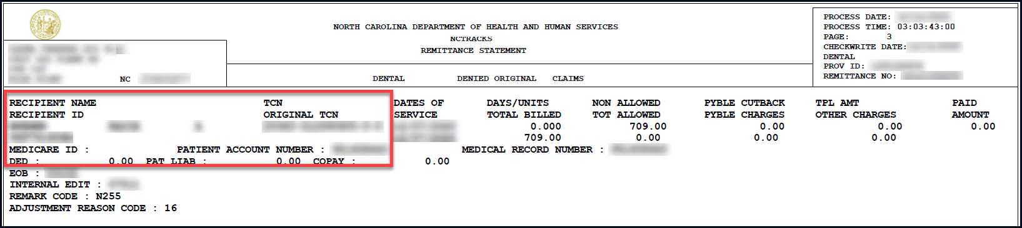
Exhibit 14-2. Denied Original Claims Page of Remittance Statement
A legend is only provided for the EOB codes. The EOB Description page is a legend for the EOB codes.
The page-header section, which appears on each page, contains the following:
- Top left: provider name and address
- Center: NC DHHS and Remittance Statement
- Top right: process date and time, page number, Checkwrite date, remittance type, provider ID, and remittance number

14.1.5 Summout Page
A Summout indicates that a provider had claim activity during the payment cycle but is receiving no payment.
- SUMMOUT (No Payment).
- A message appears on the Summout page: No payment will be received this cycle.
- If there were a payment, a Payment Header page is generated instead of the Summout page.
- A message appears on the Summout page: No payment will be received this cycle. See remittance for details.

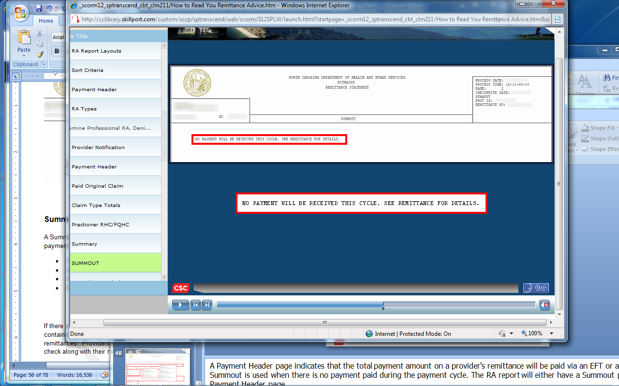
Exhibit 14-3. Summout Page of Remittance Statement

14.1.6 Payment Header Page
A Payment Header page indicates that the total payment amount on a provider's remittance is to be paid via an Electronic Funds Transfer (EFT) or a check.
If there is a payment, a Payment Header page is generated instead of the Summout page. This Remittance Statement contains only a Denied Original Claim. A Summout is not generated for providers receiving electronic remittances. Providers receiving paper remittances always receive a Summout, EFT header, or paper check along with their remittance.
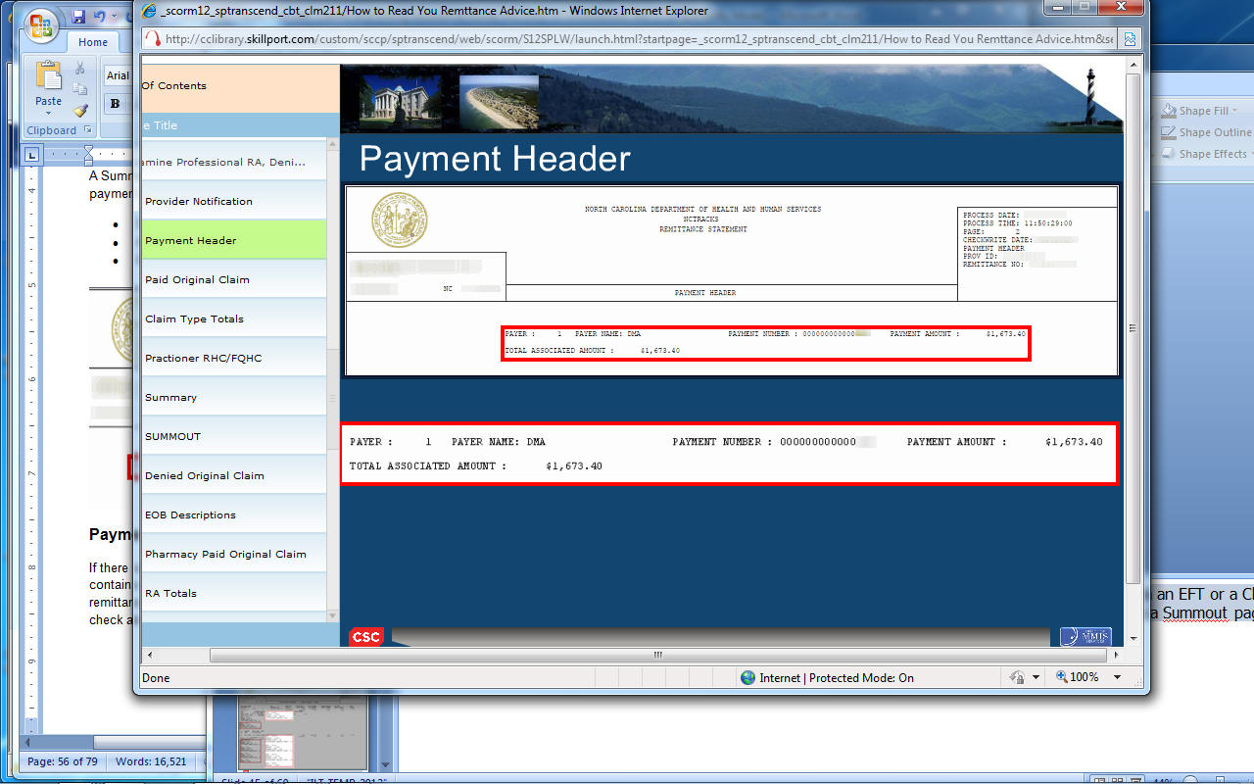

Exhibit 14-4. Payment Header Page of Remittance Statement

14.1.7 Summary Page
The Summary page Remittance lists the following information:
- Summary Totals for all claim types
- Summary of Paid Claims by benefit plan
- Month to Date Claims Financial Summary Information
- Year to Date Claims Financial Summary Information
- 1099 information as of the current Checkwrite cycle
- CLIA (Clinical Laboratory Improvement Amendments) and DEA (Drug Enforcement Agency) clarification messages

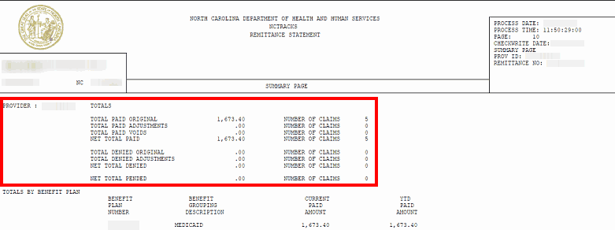
Exhibit 14-5. Summary Page of Remittance Statement

This Page Intentionally Left Blank

15. Provider Training

15.1 Provider Training and Workshop Enrollment
NCTracks provider training is accomplished through two complementary delivery methods: Instructor-Led Training (ILT) and eLearning/Computer-Based Training (CBT). This approach supports different learning styles and accommodates various work schedules. Instructor-Led Training can be attended in person or remotely via webinar.
NCTracks provider CBT courses can be taken at any time and provide important information about how to use the NCTracks system. There are also recorded webinars, participant guides, and job aids that can be downloaded for future reference, using SkillPort, the NCTracks LMS.
The NCTracks Training Tool Kits provide guidance regarding what courses should be taken based on the role in a provider’s organization, and instructions on how to use SkillPort. There is also a “Crash Course” to help providers come up to speed quickly on the system, including links to all of the key information trainees need to know, in one document.

15.2 SkillPort
SkillPort is the LMS for NCTracks. Providers can use SkillPort to register for ILT courses, whether they plan to attend in person or remotely (via webinar). SkillPort is also used to access eLearning (CBT) courses. Providers can access SkillPort from within the NCTracks Provider Portal.

15.2.1 How to Access and Register for Training in SkillPort
NCTracks provider training is accessed through the Secure Provider Portal, which requires an NCID. Users who already have an NCID can select the NCTracks Training Login button to access the secure NCTracks Provider Portal. Users who need an NCID can select the button for NCID Self Service or navigate to the NCID website at https://ncid.nc.gov and register.
Note: User NCIDs must be provisioned to access SkillPort. If you are unsure whether your NCID is provisioned for training, please contact your OA.
Once provisioned to access SkillPort, the user may navigate there and register for courses. For more information on how register for training and what classes to take, please see the following user guides on the NCTracks Provider Training page:
- How to Register for Training in SkillPort
- How to Access Online Training Sessions
- NCTracks Provider Training – What Courses Should I Take?
Top recommended provider resources in SkillPort include:
CRN | Course Title
CLM 281PUG | Submitting a Professional Claim
CLM 323 | Adding an Attachment to a Claim
PA 341PUG | Prior Approval Medical
PRV 111PUG | Provider Web Portal Applications Participant Guide
PRV 551JA | Change Office Administrator Application Process
PRV 573 | Re-credentialing
PRV 589 | Fingerprinting Application Required Process
PRV 591 | Provider Permission Matrix Instructions
PRV 596 | OPR Provider Enrollment
PRV 671 | How to Complete the Re-Credentialing – Re-verifications
RCP 181PUG | Recipient Eligibility Verification

Appendix A. Resources
Please visit https://www.nctracks.nc.gov/content/public/providers.html and look under
Quick Links on the right to find the following:
- Up-to-date contact information for NCTracks (NCTracks Contact Information document)
- Checkwrite schedules
- AVRS Features Job Aid
- NCTracks Issues List
NCTracks acronyms: https://www.nctracks.nc.gov/content/public/providers/faq-main-page/nctracks-glossary-of-terms.html
NCTracks Regional Provider Relations Representatives
NCTracks has Regional Provider Relations Representatives, serving all regions of the state of North Carolina. Provider Relations Representatives can assist with reoccurring problems with claims, enrollment, PA, issue resolution, and more. They offer individualized, one-on-one support via web meetings or phone calls. Provider site visits, web meetings, or calls can also be requested online using the NCTracks Provider Portal. Select the “Contact Us” link found at the bottom of every webpage, complete the form, select the Subject “Request a Site Visit” from the drop-down list, and select Send. A Provider Relations Representative will be in contact to schedule a site visit or call.
Note: During the COVID-19 pandemic, all site visits are suspended for the health and protection of NCTracks personnel and providers. Updates on resumption of site visits will be provided as available via announcements on the NCTracks Providers page.
Community Care of North Carolina/Carolina ACCESS Provider Information
To find your local Community Care coordinator by county, please e-mail CCNCSupport@communitycarenc.org or call 1-877-566-0943.

This Page Intentionally Left Blank

Appendix B. Referral Numbers and Points of Contact (For Providers)
Department Name | Contact Information | Reason for Referral
DHHS Customer Service Center | Phone: 1-800-662-7030 | An information and referral line to help citizens receive information and referral on human service agencies in government, nonprofit agencies, and support groups.
Clinical Policy (DHB) | https://medicaid.ncdhhs.gov/providers/clinical-coverage-policies  Phone: 919-855-4260  Fax: 919-733-2796 | Caller is a provider seeking information on number of beneficiaries they can service (policy service limitations, reimbursement rates, etc.).
Clinical Policy (DMH/DD/SAS) | https://www.ncdhhs.gov/divisions/mhddsas  Phone: 984-236-5300 / 855-262-1946  E-mail: dmh.advocacy@dhhs.nc.gov
County Department of Social Services (DSS) | https://www.ncdhhs.gov/divisions/social-services/local-dss-directory | Caller is a Medicaid beneficiary seeking the name of their case worker. Use the hyperlink to look up the caller’s county and provide the correct number.
Division of Health Service Regulation (DHSR) | https://info.ncdhhs.gov/dhsr/  Acute and Home Care Licensure and Certification:  Phone: 919-855-4620  https://info.ncdhhs.gov/dhsr/ahc/index.html  Adult Care Licensure:  Phone: 919-855-3765  https://info.ncdhhs.gov/dhsr/acls/index.html  Mental Health Licensure and Certification:  Phone: 919-855-3795  https://info.ncdhhs.gov/dhsr/mhlcs/mhpage.html  Nursing Home Licensure and Certification:  Phone: 919-855-4520  https://info.ncdhhs.gov/dhsr/nhlcs/index.html | Caller has questions about licensure requirements for a specialty regulated by DHSR.
Financial Management (DHB) | NC Medicaid Fee Schedules: https://medicaid.ncdhhs.gov/providers/fee-schedules  Rate Setting:  Phone: 919-527-7699  Fax: 919-831-1811 | Caller is questioning the reimbursement amount for a service.  Note: If the caller is from a hospital, they need to contact Hospital Rate Setting.
Financial Management (DMH/DD/SAS) | Hospital Rate Setting:  Phone: 919-527-7699  Fax: 919-831-1811  Providers that are contracted with LME/MCOs should contact the appropriate LME/MCO using the contact information provided at https://www.ncdhhs.gov/providers/lme-mco-directory.
NCHC | Providers:  https://medicaid.ncdhhs.gov/medicaid/get-started/apply-medicaid-or-health-choice/health-choice-services | Caller has questions about enrolling in NCHC or becoming an NCHC provider. General questions regarding the NCHC Program.

Additional Contacts:
Department Name | Contact Information | Reason for Referral
Health Check Program | Health Check/EPSDT (DHB Clinical Policy)  Phone: 919-855-4260  Health Check Coordination  https://www.ncdhhs.gov/assistance/childrens-services/health-check | Obtain information about EPSDT policy and procedures for EPSDT services.
Hearing and Appeals | Medicaid or NCHC recipients  https://medicaid.ncdhhs.gov/medicaid/your-rights | Information for provider to provide if recipient is denied benefits.
Medicare | Phone: 1-800-Medicare (633-4227)  http://www.medicare.gov/default.aspx  Office of Inspector General  https://oig.hhs.gov/about-oig/contact-us/ | Provider has questions regarding an OIG sanction on his/her account.
Program Integrity – Reporting Fraud and Complaints | Recipients:  https://medicaid.ncdhhs.gov/contact  Providers:  https://medicaid.ncdhhs.gov/get-involved/report-fraud-waste-or-abuse/complaint-form  Note: All callers (providers and recipients) should be encouraged to complete this confidential online complaint form. | Provider wants to report any type of fraud, waste, or abuse, or has a complaint about Medicaid or DHB.
Provider Contacts | https://medicaid.ncdhhs.gov/providers/programs-services | Provider is seeking contact information for various Medicaid departments.

Appendix C. SkillPort Training Materials
This list is current as of February 2021. For additional courses, please navigate to SkillPort.
CRN | Course Title | Learning Asset | Overview/Learning Objectives
CLM 171 | How to File a Pharmacy Claim | eLearning | - Submit pharmacy prescription drug claims via the NCTracks Provider Portal:  - Select a claim submission method  - Create a pharmacy prescription drug claim  - Save a draft claim and retrieve using Claims Draft Search  - Submit a claim and view results of claim submission  - Submit a pharmacy claim reversal
CLM 181 | How to File a Professional Claim | eLearning | - Submit professional claims via the NCTracks Provider Portal:  - Select a claim submission method  - Create a professional claim  - Save a draft claim and retrieve using Claims Draft Search  - Submit a claim and view results of claim submission
CLM 191 | How to File a Dental Claim | eLearning | - Submit dental claims via the NCTracks Provider Portal:  - Select a claim submission method  - Create a dental claim  - Save a draft claim and retrieve using Claims Draft Search  - Submit a claim and view results of claim submission
CLM 201 | How to File an Institutional Claim | eLearning | - Submit institutional claims using the NCTracks Provider Portal:  - Select a claim submission method  - Create an institutional claim  - Save a draft claim and retrieve using Claims Draft Search  - Submit a claim and view results of claim submission
CLM 211 | How to Read Your Remittance Advice | eLearning | - Understand how to read/interpret a Remittance Statement
CLM 241 | Submitting an Institutional Claim | PUG | - Create an institutional claim  - Save a draft claim and retrieve using Claims Draft Search  - Submit a claim and view results of claim submission
CLM 271 | Submitting an Institutional Claim | ILT | - Create an institutional claim  - Save a draft claim and retrieve using Claims Draft Search  - Submit a claim and view results of claim submission
CLM 281 | Submitting a Professional Claim | ILT | - Create a professional claim  - Save a draft claim and retrieve using Claims Draft Search  - Submit a claim and view results of claim submission
CLM 281PUG | Submitting a Professional Claim | PUG | - Create a professional claim  - Save a draft claim and retrieve using Claims Draft Search  - Submit a claim and view results of claim submission
CLM 291 | Submitting a Dental Claim | ILT | - Create a dental claim  - Save a draft claim and retrieve using Claims Draft Search  - Submit a claim and view results of claim submission
CLM 291PUG | Submitting a Dental Claim | PUG | - Create a dental claim  - Save a draft claim and retrieve using Claims Draft Search  - Submit a claim and view results of claim submission
CLM 311 | Submitting a Long Term Care Claim | eLearning | - Create an institutional LTC claim
CLM 321 | Submitting a Dental/Orthodontic Claim | PUG | - Create a dental/orthodontic claim via the NCTracks Provider Portal  - Save a draft claim  - Submit a dental/orthodontic claim  - Search for the status of a claim and copy the claim details to a new claim, allowing for the resubmission of the claim  - Void a previous claim  - Replace a previous claim
CLM 322 | Submitting a Professional Claim Non-Emergency Medical Transportation Providers | ILT | - Understand claims terminology  - Understand the PA process  - Create a professional claim via NCTracks  - Save a draft claim and retrieve using Claims Draft Search  - Submit a claim and view results of claim submission  - Search for the status of a claim and copy the claim details to a new claim, allowing for the resubmission of the claim  - Resubmit a claim  - Void prior claim or replacement prior claims  - Read/interpret a Remittance Statement  - Submit a PA inquiry
CLM 323 | Adding an Attachment to a Claim | JA | - Add attachments to a claim in the NCTracks Secure Provider Portal and by mail such as Admittance Summary, Medical Records, Ambulance Trip Ticket, Certifications, Diagnosis Report, Invoice, Discharge Summary, EOB, physician’s orders, etc.
CLM 323 | Add Attachment to a Claim | JA | - Add attachments to a claim in the NCTracks Secure Provider Portal and by mail
CLM 402 | Submitting a Time Limit Override Request Using NCTracks | ILT | - Indicate Time Limit Override request using the Delay Reason field on a claim  - Understand the Delay Reason Code  - Attach an EOB document to a claim  - Submit a claim
GEN 100 | Helpful Hints for Dental Prior Approval and Claims Submission | ILT | - Identify the available methods of PA submission  - Identify how to upload documents when submitting PA via NCTracks or to existing PA  - Identify the most common errors when completing American Dental Association (ADA) form  - Identify common errors that require requests for PA additional information  - Identify the common mistakes when submitting claims
GEN 102 | ICD System Changes for Provider | eLearning | - Identify the NCTracks system changes as they relate to ICD-9 and ICD-10 in institutional, pharmacy, professional, and dental claim types  - Navigate through entering a PA request for ICD-10 for medical and dental PA types
GEN 111 | NCTracks Overview – Provider Portal (Provider) | eLearning | - Navigate to the public Provider Portal on NCTracks  - Navigate to the Secure Provider Portal  - Access messages, links to online resource, and news feeds  - Select the appropriate icon or drop-down menu option for commonly performed tasks
GEN 171 | AVRS Features | JA | - Understand available features of the NCTracks AVRS
GEN 181 | Contact Guide | JA | - Provides the reason for referral and contact information for each relevant department
GEN 201 | Provider Adjustment, Time Limit & Medicare Override | JA | - Perform adjustments on a claim document. The claims adjustment process gives providers an opportunity to request a review or correct a previously processed claim that has either paid or denied.
PA 261 | Prior Approval Requests and Inquiry | eLearning | - Enter a PA request  - Inquire on an existing PA request
PA 331 | Prior Approval Institutional | ILT | - Submit PAs and Managed Care Referrals electronically  - Conduct electronic inquiries about PAs, and Managed Care Referrals and Overrides
PA 331PUG | Prior Approval Institutional | PUG | - Submit PAs and Managed Care Referrals electronically  - Conduct electronic inquiries about PAs, and Managed Care Referrals and Overrides
PA 105 | Pharmacy Prior Approval Inquiry | JA | - Conduct inquiries on PAs where the provider is listed as the submitting, billing, and/or rendering provider  - View PAs completed by MedSolutions, Carolinas Center for Medical Excellence (CCME), and other vendors in NCTracks
PA 341 | Prior Approval Medical | ILT | - Submit PAs and Managed Care Referrals electronically  - Conduct electronic inquiries about PAs, and Managed Care Referrals and Overrides
PA 341PUG | Prior Approval Medical | PUG | - Submit PAs and Managed Care Referrals electronically  - Conduct electronic inquiries about PAs, and Managed Care Referrals and Overrides
PA 351 | Prior Approval Dental | ILT | - Submit PAs and Managed Care Referrals electronically  - Conduct electronic inquiries about PAs and Managed Care Referrals and Overrides
PA 351PUG | Prior Approval Dental | PUG | - Submit PAs and Managed Care Referrals electronically  - Conduct electronic inquiries about PAs and Managed Care Referrals and Overrides
PA 361 | Long Term Care Prior Approval Request | eLearning | - Submit an LTC PA request using the FL2 form  - Inquire on a PA status
PA 371 | Prior Approval Dental/Orthodontic | PUG | - Submit dental PA requests  - Inquire about dental PA requests
PA 151 | Pharm PA Short Long acting Prefer/Non prefer drugs | JA | - Identify the NCTracks system changes involving PA for Short-Acting and Long-Acting Opioid Analgesics
PA 374 | Dental, Optical, Physician Fluoride Varnish, and Durable Medical Equipment (DME) and Orthotic and Prosthetic (O&P) Service Inquiry Training | ILT | - Submit an Eyeglass Confirmation service request  - Submit a Refraction Confirmation service request  - Submit a Dental Benefit Limitation service request  - Submit a Physician Fluoride Varnish Limitation service request  - Submit a DME/O&P Service History request
PA 375 | Dental, Optical, Durable Medical Equipment (DME), Physician Fluoride Varnish and Orthotic and Prosthetic (O&P) Prior Approval Service Inquiry | eLearning | - Submit an Eyeglass Confirmation service request  - Submit a Refraction Confirmation service request  - Submit a Dental Benefit Limitation service request  - Submit a Fluoride Varnish Limitation service request  - Submit a DME/O&P Service History request
PA 333 | Prior Approval: Private Duty Nursing | JA | - Submit PA requests for services, products, and/or procedures electronically using the PA Entry screen in the Provider Portal
PA 342 | Prior Approval: Hearing Aid | JA | - Submit PA requests for hearing aids
PA151PUG | Prior Approvals and Managed Care Referrals & Overrides Participant User Guide | PUG | - Submit PAs and Managed Care Referrals electronically  - Conduct electronic inquiries about PAs and Managed Care Referrals and Overrides
PA372 | PA for Medicaid for Pregnant Women (MPW) Chiropractic and Podiatry Services | ILT | - Understand the changes to the process for referrals and PA for MPW chiropractic and podiatry services  - Enter PA requests in NCTracks  - Search for PA requests in NCTracks
PA 373 | Dental, Optical, Durable Medical Equipment (DME), Physician Fluoride Varnish and Orthotic and Prosthetic (O&P) Prior Approval Service Inquiry Provider | JA | - Submit an Eyeglass Confirmation service request  - Submit a Refraction Confirmation service request  - Submit a Dental Benefit Limitation service request  - Submit a Fluoride Varnish Limitation service request  - Submit a DME/O&P Service History request
PA 380 | CAP Respite Service History | JA | - Access PA entry functions  - CAP Respite Service History  - Inquiry messages  - Inquiry messages for Authorized/Paid Units and Procedure Code H0045 Dates
PA151JA | Pharmacy Provider Prior Approval Short-Acting and Long-Acting Preferred and Non-Preferred Drugs | JA | - Identify the NCTracks system changes involving PA for Short-Acting and Long-Acting Opioid Analgesics
PA600 | Pharm PA SC DPH | ILT | - Electronically submit and inquire about Pharmacy PA requests for DPH Sickle Cell recipients
CO101 | ORH COVID-19 Testing Claims Submission | JA | - Access Provider Portal in NCTracks  - Access Uninsured NC Residents COVID-19 Related Services Payment Request Page  - Create ORH COVID-19 claim  - Access ORH COVID-19 Claim Search Page  - Access ORH COVID-19 Claim Details Page
HIE 101 | NC Health Information Exchange (HIE) Network Status and Hardship | JA | - Understand how NCTracks allows OAs to view a provider’s HIE Network status and the process to request a hardship extension
PRV111 | Rendering/Attending Provider Changes | JA | - Understand the NCTracks system changes regarding rendering/attending providers and CCNC/CA
PRV111 | Provider Web Portal Applications | PUG | - Understand the Provider Enrollment Application processes  - Navigate to the NCTracks Provider Portal and complete Provider Enrollment, MCR, Re-enrollment, Re-verification, and Maintain Eligibility processes  - Track and submit applications using the Status and Management page
PR145 | Enrollment Process for Behavioral Health Providers | JA | - Understand the NCTracks system changes to the Provider Enrollment Process for behavioral health providers. Effective July 1, 2017, Medicaid behavioral health providers requesting an initial enrollment through LME-MCOs must be directed to NCTracks.
PR402 | Four Schools Batch Enrollment Process | JA | - Upload batch enrollment files, check the status of a batch enrollment file, and complete the batch enrollment file (Four Schools: Duke University, University of North Carolina [UNC], East Carolina [ECU], and Wake Forest University)
PR451 | Processing DME Claims with PAs, Using Local W Codes | JA | - Correctly process claims when submitting multi-line PA requests with multiple state/local “W” codes
PR374 | PRV374 Submitting An Optical (Eyeglasses and Refraction) Service Inquiry | ILT | - Submit an Eyeglass Confirmation service request  - Submit a Refraction Confirmation service request
PR3741 | Submitting Dental Benefit Limitation Inquiry | ILT | - Submit a Dental Benefit Limitation service request
PR3742 | Submitting Physician Fluoride Varnish Service Inquiry | ILT | - Submit a Physician Fluoride Varnish Limitation service request
PR381PUG | Professional Claims Participant User Guide – DPH | PUG | - Create a professional claim  - Save a draft claim and retrieve using Claims Draft Search  - View results of a claim submission
PR551JA | Change Office Administrator Application Process | JA | - Change the OA associated with a provider’s record (NPI/Atypical ID)
PR411 | Provider Records – Functions and Impacts | eLearning | - Discern the structure of provider records  - Identify the functions and impacts of provider records
PR461PUG | Provider User Provisioning – Participant Guide | PUG | - Establish an OA  - Access and navigate the User Administration section of the Secure Provider Portal  - Add, maintain, and delete provider groups  - Add, maintain, and delete users  - Disable, enable, and reset users’ Electronic Signature PINs
PR481PUG | Pharmacy Prior Approval Participant User Guide | PUG | - Submit PAs electronically  - Upload PA attachments  - Submit real-time PA inquiries (adjudication status, units allowed and used, and dollars allowed and used)
PR501 | Office Admin Functions | eLearning | - Understand the functions of an OA  - Add, maintain, and delete Provider Groups  - Add, maintain, and delete User Administrators and General Users  - Understand functions of the User Administrator and the General User  - Reset an Electronic Signature PIN
PR511 | Updating Provider Data (Provider) | eLearning | - Access and navigate through the MCR screens  - Add and update provider information on the MCR screens
PR531 | Provider Web Portal Applications | ILT | - Understand the Provider Enrollment Application processes  - Navigate to the NCTracks Provider Portal and complete the Provider Enrollment, MCR, Re-enrollment, Re-verification, and Maintain Eligibility applications  - Track and submit applications using the Status and Management page
PR531PUG | Provider Web Portal Applications | PUG | - Understand the Provider Enrollment Application processes  - Navigate to the NCTracks Provider Portal and complete the Provider Enrollment, MCR, Re-enrollment, Re-verification, and Maintain Eligibility applications  - Track and submit applications using the Status and Management page
PR560 | Create and Submit a Prior Approval for Home Health using Electronic Physician Signature | JA | - Submit PA request/electronic signature for Requesting Provider and Prescribing Provider user roles
PR561 | Change Office Administrator Application Process | JA | - Change the OA associated with a provider’s record (NPI/Atypical ID)
PR564 | Assign the Enrollment Specialist User Role and Assign/Reassign Applications. | JA | - Assign the ES role to a user
PR565 | Upload Supporting Documents to Various Applications | JA | - Understand the process for uploading documents for a provider enrollment application (initial Enrollment, Re-enrollment, MCR, Maintain Eligibility, or Re-verification)
PR562 | Enrollment Specialist | PUG | - Understand the Enrollment Specialist User Role  - Navigate the NCTracks Provider Portal to complete a Provider Enrollment, MCR, Re-enrollment, Re-verification, or Maintain Eligibility application  - Assign completed applications to the OA
PR563 | Abbreviated Manage Change Request | PUG | - Update EFT information  - Add/update Affiliations  - Add/update Method of Claim and Electronic Transactions and/or Billing Agent  - Complete multiple changes or review the authorized user’s complete provider record
PR569 | Create and Submit a Prior Approval (PA) for DME using Electronic Physician Signature | JA | - Understand the step-by-step process for the PA request/Electronic signature for Requesting Provider and Prescribing Provider user roles
PR573 | Re-credentialing | JA | - Understand the purpose and requirements for provider Re-credentialing  - Understand the steps for completing the Re-credentialing/Re-verification processes through NCTracks
PR574 | Provider Message Center | JA | - Access the Nursing Facility Rate and Patient Roster letters in the Provider Message Center Inbox
PR577 | Submitting an Ambulance Claim for Providers | JA | - Submit a professional or institutional claim (ambulance providers)
PR575 | Provider Message Center Inbox – WebEx | ILT | - Navigate within the Provider Message Center  - Search for and retrieve messages
PR578 | Enrollment Process for Therapeutic Foster Care Providers | JA | - Complete an enrollment application within NCTracks (Therapeutic Foster Care providers)
PR581 | Enrolled Practitioner Search | JA | - Access and use the Enrolled Practitioner Search feature of NCTracks
PR579 | Submitting an Ambulance Claim for Providers – WebEx | ILT | - Create a professional or institutional claim  - Submit a professional or institutional claim and view results of claim submission
PR580 | How to Add/Update Credentials for Providers | ILT | - Add/update provider accreditation, certification, or license
PR582 | Provider Web Portal Applications – NEMT | ILT | - Understand the Provider Enrollment Application process for NEMT providers  - Navigate to the NCTracks Provider Portal and understand how to complete initial Enrollment, Re-enrollment, Re-verification, Abbreviated MCR, MCR, and Maintain Eligibility application processes
PR583 | County DSS NEMT – Enrollment, Payment Authorization Submission, and Prior Approval Inquiry | ILT | - Enroll as a Billing Agent to allow for the submission of Payment Authorization batches  - Update the Method of Claims Submission on an existing provider record to allow for the submission of Payment Authorization batches  - Create Payment Authorization batches  - Upload Payment Authorization batches  - Search for NEMT PAs
PR584 | Helpful Hints for Dental Prior Approval And Claims Submission | ILT | - Identify the available methods of PA submission  - Identify how to upload documents when submitting PAs via NCTracks or to existing PA  - Identify the most common errors when completing ADA form  - Identify common errors that require requests for PA additional information  - Identify the common mistakes when submitting claims
PR584_PDF | Helpful Hints for Dental Prior Approval And Claims Submission | ILT slides in a PDF format | - Identify the available methods of PA submission  - Identify how to upload documents when submitting PAs via NCTracks or to existing Prior Approval  - Identify the most common errors when completing ADA form  - Identify common errors that require requests for PA additional information  - Identify the common mistakes when submitting claims
PR589 | Fingerprinting Application Required Process | JA | - Understand how to complete the Fingerprinting Required application process in NCTracks
PR591 | Provider Permission Matrix Instructions | JA | - Understand how to use the Provider Permission Matrix spreadsheet to identify provider enrollment requirements
PRV586 | Traumatic Brain Injury Waiver | ILT | - Define the Traumatic Brain Injury (TBI) Waiver  - Identify the TBI Benefit Plan in Recipient Eligibility  - Understand the TBI encounter claims received from the LMEs/MCOs
PR587 | Helpful Hints for Orthodontic Prior Approval Submission | ILT | - Identify the available methods of PA submission  - Identify how to upload documents when submitting PA requests via NCTracks and how to upload documents to existing PA requests  - Identify the most common errors when completing ADA form  - Identify common errors that require requests for PA additional information  - Request payment for orthodontic records  - Submit PA requests for orthodontic treatment requiring orthognathic surgery  - Use the Orthodontic PA attachment forms
PR593 | Hospice Rate Changes | JA | - Understand the two-tier rate calculation and End of Life Service Intensity Add-on (SIA) payments
PR598 | Pharmacy Prior Approval Requirements for Nucala | JA | - Submit initial PA requests and reauthorization requests for Nucala
PR594 | Other Payer Detail on Claim | ILT | - Submit a professional claim via the NCTracks Provider Portal and include Other Payer detail
PR595 | OOS Provider Enrollment | PUG | - Understand how to enroll as an OOS provider
PR596 | OPR Provider Enrollment | PUG | - Submit an OPR Lite Enrollment application  - Convert from an OPR Lite provider to an OPR Full provider with an MCR
PR599 | Pharmacy Prior Approval Requirements for Epinephrine Auto Injectors | JA | - Submit PA requests for Preferred and Non-Preferred Epinephrine Auto Injectors
PR599 | Pharm PA Requirement – Epi Injectors | JA | - Submit PA requests for Preferred and Non-Preferred Epinephrine Auto Injectors
FSPRV604 | Changes to Individual Provider Application Process for Four Schools | ILT | - Identify how NCTracks captures and stores work history (including work history gaps), education history, and current malpractice insurance information  - Understand requirements for individual enrolling providers to submit ALL board certification data, answer Exclusion Sanction questions, and sign provider agreement
PRV604 | Changes to Individual Provider Application Process | ILT | - Identify how NCTracks captures and stores work history (including work history gaps), education history, and current malpractice insurance information:  - Understand requirements for individual enrolling providers to submit ALL board certification data, answer Exclusion Sanction questions, and sign provider agreement
PR603 | Advanced Medical Home Tier Attestation | JA | - Complete the AMH Tier Attestation process in NCTracks
PR651 | How to Add or Update Electronic Funds Transfer (EFT) Information in NCTracks | JA | - Add or update EFT information in NCTracks
PR661 | How to Change the Physical Address in NCTracks | JA | - Change a provider’s physical address using the MCR process in NCTracks
PR662 | How to Change the Correspondence Address in NCTracks | JA | - Change a provider’s correspondence address using the MCR process in NCTracks
PR671 | How to Complete the Re-Credentialing –  Re-verifications | JA | - Understand the steps for completing the re-credentialing process (otherwise known as re-verification) in NCTracks
PR681 | How to Add or Change a Billing Agent and Other Claim Submission | JA | - Add or change a billing agent and use other claim submission options in NCTracks
PR691 | How to View or Update Provider Taxonomy | JA | - View and change taxonomy codes for provider profiles
PR701 | Unable to Enter EIN – Receive the Error Message – Enter 9 or Fewer Characters | JA | - Understand/resolve the error message ‘You must enter text with 9 or fewer characters’ when entering provider EIN in NCTracks
PR911 | Review and Implement DME Claims Processing | ILT | - Process a DME Professional claim  - Edit and resubmit a claim  - Request a Time Limit Override
PR911PUG | Review and Implement DME Claims Processing Participant User Guide | PUG | - Process a DME Professional claim  - Edit and resubmit a claim  - Request a Time Limit Override
PR912 | Provider Web Portal Applications – NEMT | PUG | - Understand the Provider Enrollment Application processes  - Navigate to the NCTracks Provider Portal and complete the Provider Enrollment and MCR application processes  - Track and submit applications using the Status and Management page
PR702 | Request to Back-Date Enrollment Effective Dates | JA | - Submit a request to back-date all Health Plans, service locations, taxonomy codes, and services (if applicable) to the same date  - Submit a request to back-date one Health Plan, service location, taxonomy code, or service (if applicable)  - Understand back-dating approval or denial notification
PR703 | Sub Disaster Relief ProEnroll App | JA | - Access the NCTracks Provider Portal to complete and submit a Disaster Relief abbreviated enrollment application
PR602 | Advanced Medical Home Tier Attestation | ILT | - Define AMH  - Understand AMH tier assignments  - Complete the AMH Tier Attestation process in NCTracks
PR711 | How to Add Billing and Rendering Provider Taxonomy Information to a Claim | JA | - Resolve the edit code 07011 INVLD BILLING PROTAXON CODE
PR721 | How to Indicate Other Payer Details or an Override on a Claim in NCTracks and Batch Submissions | JA | - Indicate “Other Payer” details on a professional claim in NCTracks
PRV241 | Applying For and Maintaining CCNC_CA Enrollment | JA | - Enroll and maintain participation in CCNC/CA within NCTracks
PRV242 | Changing or Terminating CCNC_CA Enrollment | JA | - Change or terminate participation in CCNC/CA within NCTracks by completing an MCR
RCP 131 | Viewing Recipient Information | eLearning | - Access recipient eligibility information via the Provider Portal  - Review and verify recipient eligibility information on the Provider Eligibility Response screen
RCP 161 | Recipient Eligibility & Verification (Medical) | ILT | - Submit consent forms and access status  - Perform inquiries for recipient eligibility and navigate to eligibility responses  - Upload files for batch eligibility inquiries and navigate to response screens
RCP 181 | Recipient Eligibility Verification | ILT | - Submit an individual recipient eligibility inquiry  - Submit a batch eligibility inquiry  - View an eligibility response
RCP 181 | Recipient Eligibility Verification – Provider – WebEx | ILT | - Verify a recipient’s Identity, Current eligibility, Health Plan, Benefit Plan, Service Type and Co-pay, Category of Eligibility, County Code
PR912 | Provider Web Portal Apps NEMT | PUG | - Understand the Provider Enrollment Application processes  - Navigate to the NCTracks Provider Portal and complete the Provider Enrollment and MCR provider application processes  - Track and submit applications using the Status and Management page
RCP 281 | Recipient Eligibility Verification Participant User Guide (DPH Providers) | PUG | - Submit an individual recipient eligibility inquiry  - Submit a batch eligibility inquiry  - View an eligibility response
RCP 301 | PHP Eligibility/Enrollment for Providers | JA | - Review the Managed Care (MC) plan information for a beneficiary
RFR 171 | Pharmacy Coverage Inquiry | eLearning | - Verify whether a drug/product is covered, by NC DHHS Payer, Benefit Plan, or DOS (pharmacy providers)
RFR 181 | Pharmacy Drug Type Forms | JA | - Understand changes in the NC Medicaid and NCHC Preferred Drug List (PDL) including:  - Addition of PA drug type forms for Juxtapid, Crinone, Off Label Antipsychotic Safety Monitoring in Children through Age 17 (AKIDS), and Adult Safety with Antipsychotic Prescribing (ASAP)  - Removal of stand-alone drug type forms for Lyrica, Lamictal, and Topamax  - Access and accurately complete the Juxtapid, Crinone, AKIDS, and ASAP drug type forms  - Access the Non-Preferred drug type form
RFR 182 | Discontinued Drug Class Forms | JA | - Understand changes in the NC Medicaid and NCHC PDL including:  - Discontinuation of the AKIDS and ASAP drug class paper forms  - Rejection/return of AKIDS and ASAP records submitted from Infina as errors
RFR 183 | A+KIDS Drug Type Forms | JA | - Understand changes in the NC Medicaid and NCHC PA criteria including discontinuation of the A+KIDS) drug class paper forms  - Access A+KIDS drug type forms via the NCTracks Secure Provider Portal  - Submit A+KIDS PA requests via the NCTracks Secure Provider Portal
RFR 184 | ASAP Drug Type Forms | JA | - Access ASAP drug type forms via the NCTracks Secure Provider Portal
RFR 185 | Hepatitis C Agents Pharmacy Prior Approval (PA) Request | JA | - Access the NCTracks Secure Provider Portal to submit Hepatitis C Agents Pharmacy PA requests for Sovaldi, Olysio, Harvoni, and Viekira Pak
RFR187 | PA Criteria for Relistor and Gattex Drug Class | JA | - Identify the PA criteria for the drug class for the Selective Constipation Agents (SCAs) Peripherally Acting drug Relistor for initial coverage and reauthorization and the PA criteria for Gattex for initial coverage and reauthorization
PR3743 | Submitting Durable Medical Equipment (DME)/Orthotic and Prosthetic Service History Inquiry | ILT | - Submit service inquiries for DME/O&P service history using the NCTracks Provider Portal

Providers of DMH/DD/SAS State-funded services will continue to contact their contracted LME.

